Jeffrey Mansion Alcohol Policy Framework
(passed August 28, 2012; amended September 11, 2012)

It is the intent of this Jeffrey Mansion Alcohol Policy Framework to allow for limited and responsible permitting of alcohol at Jeffrey Mansion during special events at the mansion.

Role of the Recreation Board
The Recreation Board shall author and administer a Jeffrey Mansion Alcohol Policy. The Recreation Board has the right to define and restrict the Jeffrey Mansion alcohol policy beyond the framework outlined herein.

In addition to, or as a part of, the Recreation Board created Jeffrey Mansion Alcohol Policy, the Recreation Board shall establish clear internal standards and directives to address the following:
- Evaluation: Prior to the enactment of a Jeffrey Mansion Alcohol Policy, the Recreation Board shall establish a process and standards by which to regularly evaluate the effectiveness of the alcohol policy in promoting responsible stewardship of the mansion facility and the city’s financial position.
- Enforcement: The Recreation Board shall establish methods by which to enforce responsible conformance to the Jeffrey Mansion Alcohol Policy by users of the facility.
- Communication: Requirements of users of the Mansion and enforcement measures must be clearly communicated via rental forms, etc, and also via any promotional material.
- Creation and Modification of the Jeffrey Mansion Alcohol Policy: The Jeffrey Mansion Alcohol Policy will not go into effect until voted on and passed by a simple majority of the Bexley Recreation Board. Any changes of the policy thereafter will also require passage by a simple majority of the Bexley Recreation Board.
- Legal Issues: The Recreation Board shall have the draft Jeffrey Mansion Alcohol Policy reviewed by legal counsel prior to submittal to Bexley City Council for review.

Rental Rate Structure
It is not the intent of this policy to alter rental rates for events in which alcohol is not being permitted. Therefore, rental rate structures for Jeffrey Mansion will remain the same except for the following changes:
- An alcohol surcharge will be assessed to any event that would like to have the use of alcoholic beverages. The alcohol surcharge rate shall be established by the Recreation Board.

Hours of Permitted Use
- Rentals in which the serving of alcohol is permitted will be required to fall into specific time windows on Fridays, Saturdays and Sundays.

Approved Caterers
A list of approved preferred caterers will be created for events.
- Preferred caterers will be required to obtain and maintain personal injury and/or property damage liability insurance coverage of no less than a $1,000,000; automobile liability insurance of an amount no less than $1,000,000; and liquor liability insurance of no less than $1,000,000. The City of Bexley shall be included as an additional insured on the caterer’s certificate of insurance.
- Caterers will pay a fee to the Recreation Department for each event at which they serve.
- In order to have alcoholic beverages at an event, customers must work with one of the preferred caterers.
  - If alcohol will not be consumed at the event, then customers may work with any caterer they choose.
- Approved caterers will be interviewed and pre-approved by the Bexley Recreation Board.
- In order to remain on the preferred caterer’s list, the caterer must leave the mansion in the condition it was in prior to the event, to the satisfaction of the Recreation Director.

Caterer’s Responsibility
- Caterers will have a separate contract with customers from that of the rental contract.
- Customer will make a payment to the Bexley Rec for the Jeffrey Mansion and a payment to the preferred caterer of choice for food services.

Security
- Any private event in which alcohol is consumed must have at least 1 special duty police officer for the entire length of the event. Said officer must be hired and paid for by the customer. The City of Bexley reserves the right to require the customer to hire additional police officers depending on the total number of guests present.
- Special duty officers must be hired by going through the Bexley Police Department.
- Alcohol consumption must comply with all Bexley Ordinances, Ohio Revised Code, and any and all governing laws.
- Bexley Police Department retain the authority to order the renters/participants to cease all activities and leave the premises if it is determined that is in the best interests of safety.

Designated Areas
- Alcohol consumption is strictly limited to designated areas. The designated areas specified in this policy may be further restricted by action of the Recreation Board. These areas include the Jeffrey Mansion building, patio, and the adjacent first landing located on the west side of the Jeffrey Mansion (Landing with the gazebo). The designated areas are shaded in blue and outlined in red in the aerial photograph below:

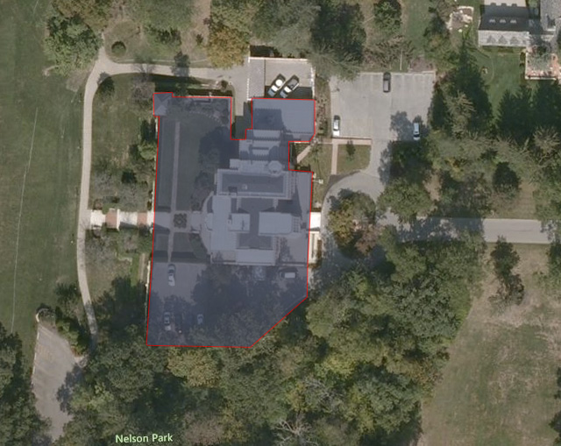

Restrictions on Rentals
- Events in which alcohol is being served may only be booked by residents of the City of Bexley. Residents may also book the mansion as sponsors for non-residents, provided that they remain a point of contact and the liable party throughout the rental process.

Review of the Jeffrey Mansion Alcohol Policy by Bexley City Council and Mayor
- Within 30 days prior to voting on the passage of a new or modified Jeffrey Mansion Alcohol Policy, the Recreation Board shall provide members of Bexley City Council and the Mayor of Bexley a written copy of the same for review and comment.

Council Approved: August 28, 2012
Amended: September 11, 2012

