Hi All,

I hope you’re doing wonderfully!

Here are the highlights from this past Tuesday’s meeting:
- I spoke with two Rumpke employees who told me they feel unsafe doing their job because our residents don’t bag their trash.
- Please let me know if you have ideas for SWACO’s Community Waste Reduction Grant. The application is due at the end of August.
- We’re going to have a monthly column (beginning in September) in Bexley Living and Green Bexley issue in April, 2021. Please let me know if you’d like to contribute. All articles will be run by Sam. Some ideas are:
  - Monthly column:
    - September- reintroduction to sustainability in Bexley and the ZWP
    - October-
    - November- food waste reduction (in anticipation for the holidays)
    - December- green your home for the winter
    - January-
    - February-
    - March- Green your home for the spring
  - Green Bexley Living
    - Instead of one feature family, highlights of a multitude of families who incorporate sustainable practices for a variety of reasons (the Smith family’s religion teaches them to repair the world, so they plant a tree every year; Mikey Jones’s grandmother had asthma, so he utilizes low impact transportation in her honor; Geri’s mother always told her there were starving children in Europe so she now ensures no food goes to waste; etc.)
      - Other ideas: plastic is an endocrine disruptor, saving money, like to eat and therefore wanting to protect the pollinators, not feeling you have the right to live in a way that negatively impacts the 7 billion + other people and plants and animals who live on the planet, for environmental justice, you like being outdoors, you hate when your basement floods all while Australia is on fire and wish there were fewer and less extreme weather events, you want your kids to grow up happy and health, etc.
    - Regular columns
      - resident recipe featuring a sustainable dish, perhaps something where you can easily use up a variety of foods you have at home before you go bad, using parts of food you didn't think you could use (like carrot tops, beet greens, etc.)
      - living spaces can feature things you can do around the home to be more eco-friendly, such as smart thermostats, bidets, etc.
      - managing wealth can discuss divesting from fossil fuels
      - parenting helping your child manage climate anxiety
      - what drives us hybrid and electric cars, and lower impact transportation
      - home matters/house trends ways to build, remodel, or furnish your home sustainably, and/or quick things you can do around the home to save energy or tips to implement new sustainable routines, such as using cloths instead of paper towels, etc.
      - kids' korner things kids can do around their home and community to go green- pick up litter, advocate to their parents to enhance their recycling or composting practices, talk to their friends about sustainability, etc.
      - healthy living discuss the health benefits of many foods that can be purchased free of packaging
      - senior living tips or words of wisdom from seniors who live very sustainably- recipes using all parts of food, tips to save soap, freezing food so it doesn't go to waste, saving jars and bags so they can be reused, etc
      - lawn & garden can include ways to water your lawn sustainably, remove weeds and bugs in a safe manner, use cover crops after the growing season to assist your garden and also the environment, using composing in your garden, not tilling your garden, etc.
    - getting sponsorships/ads from sustainable companies or companies promoting sustainable products
    - Using recycled paper and soy ink, or at least acknowledging that fact that we didn’t do that
- Our Instagram follows increased significantly when Darin Olien of Down to Earth with Zac reposted something I wrote.
- Corporate Giant Eagle has banned reusable bags, but they aren’t necessarily enforcing it.
- Approx. 1325 households are signed up for composting; George is seeing some contamination re the types of bags used and what is in the bags.
- R:e a Drop Off Facility- I was able to connect with Big Breen Box battery recycling in Lancaster and will get more info on what they can offer us.
- From the programming front, the Fair is on hold, as is Boot Camp in the traditional sense, but Kathy + team are looking to plan for the future. I’m going to be on Cleveland’s Youth Ambassador Program’s working group to help develop their program with the intent of learning what, if anything, we’d want/be able to implement here. Also, in September/October, I might see if teachers are interested in a Zoom call with an eco guest speaker, project based learning activities, or anything else I can offer.
- We’re looking to launch Love Your Alley in the fall.
- Carol introduced an idea for some working groups re: policy, etc.
- Kathy is in touch with someone who can speak to us/ the community on environmental justice.
- Other fun things: Holiday Boutique uses the hair they cut in their gardens, I haven’t yet heard back from the other salons I contacted.
- We have decided to have a meeting on August 18th, for anyone who is able to make it.

I made a graph of our Rumpke trash weights; I am unsure if this is solely residential weights. This graph assumes a) this is the metric we’re using and b) 2018 is our baseline for 90% reduction. My assumptions may be incorrect, however.

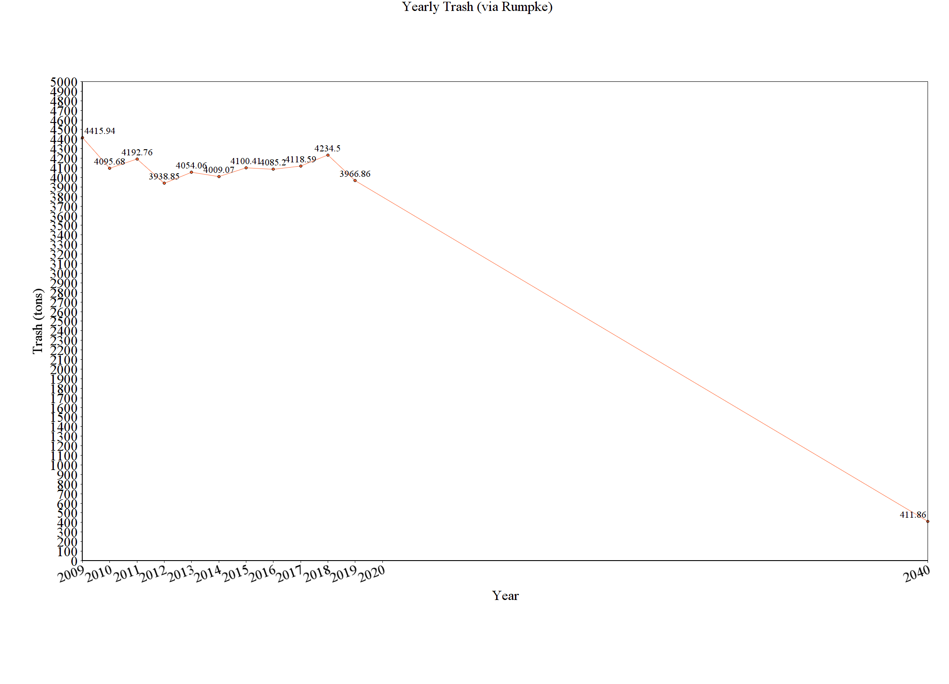
Here is some info I pulled together from the ZWP.

The Bexley community will significantly reduce its contribution to the landfill through sustainable initiatives for residents, businesses, institutions, and industries by improving public engagement, education, and infrastructure (ZWP 2-1)

The City of Bexley will accomplish the Zero Waste objective by 2040 or sooner when it achieves a 90% reduction of materials disposed at the landfill. The recommendations will be implemented in Phases and the ZWP will be updated by the City of Bexley Green Team every five years or earlier as determined by City Council (ZWP 1-6)

Note: Each sector also had its own list of objectives, which are typically to evaluate various things.

Green highlights are completed actions.
Red highlights are abandoned actions.

ZWP to be updated 5 years from 2017/2018, or sooner, as Council deems appropriate.
Recommended Actions for Residential Sector (3-21 and 3-22)
Phase 1 (2018-2023) | Phase 2 (2024-2030) | Phase 3 (2031-2040)
Toters for single family homes | MFH Recycling
Contract reviewed and pay-as-you-throw and semi or fully automatic collection explored | Contract reviewed and pay-as-you-throw and semi or fully automatic collection explored
Back yard composting encouraged | SWACO addressing hard-to-recycle materials (including plastics 3-7)
Yard waste collection at curb for those not interested in back yard composting
Composting pilot program for residents and businesses
Educational program emphasizing existing collection opportunities for HHW, electronics, textiles
Explore partnership with other communities for textile recycling
Reducing plastic bags
Electronics drop-off
Increase data collection to issue plan and complete studies
Eliminate backdoor service

Recommended Actions for Business Sector (4-19 and 4-20)
Phase 1 (2018-2023) | Phase 2 (2024-2030) | Phase 3 (2031-2040)
Get info re recycling for businesses | Establish Green Teams within commercial and Industrial business
Form stakeholder group to discuss topics | Develop business plan with tasks and dates for recycling
Implement mandatory recycling | Conduct general business-specific waste audits
Expand reuse and source reduction of waster materials within businesses | Implement special waste recycling and reuse programs to manage special wastes, including electronics
Develop short and long term business plans for commercial and industrial compost | Work with businesses to improve contracting, auditing and dumpster service
Conduct inventory of businesses to be targeted by compost program | Conduct selected waste audits for one or more targeted businesses
Require policy for pairing of trash and recycling containers | Revise long term plan if necessary based on pilot project results
Promote education and development of greater plastics recycling | Adopt policies promoting purchase of recycled-content, or environmentally sustainable products.
 | Establish specifications for all construction projects which require construction and demo debris to be reused or recycled
 | Develop communication plan as part of education program targeted at business owners and waste management programs.

Recommended Actions for Educational Sector (5-18 and 5-19)
Phase 1 (2018-2023) | Phase 2 (2024-2030) | Phase 3 (2031-2040)
Contracting, auditing, and dumpster service | Construction and demo debris
Purchase recycled-content products | Events
Waste sorts
Special Wastes
Reuse and waste reduction
Data collection
Communication Plan

Recommended Actions of City (5-26)
Phase 1 (2018-2023) | Phase 2 (2024-2030) | Phase 3 (2031-2040)
Create ESAC | Contracting, auditing, and dumpster service
Website | Construction/Demo policy
Recycling containers- consistency | Policy for purchasing recycled-content products
“Green” special events

Recommended Education and Promotion of ZWP (6-8)
Phase 1 (2018-2023) | Phase 2 (2024-2030) | Phase 3 (2031-2040)
Establish Education and Outreach Planning Subcommittee | Create education signs to brand ZWP for high traffic areas
Develop schedule to present ZWP to community | Provide businesses that recycle a sign to advertise
Develop specific plan for informing residents about new programming
Work with BCS to schedule professionals to educate students and faculty
Work with Capital Sustainability Council establish data needs and working relationship with City
Coordinate with IT for social media material
Web based directory
Create list of local haulers for commercial sector have this listed online
Map out Drop-off recycle locations within 2 mile radius

