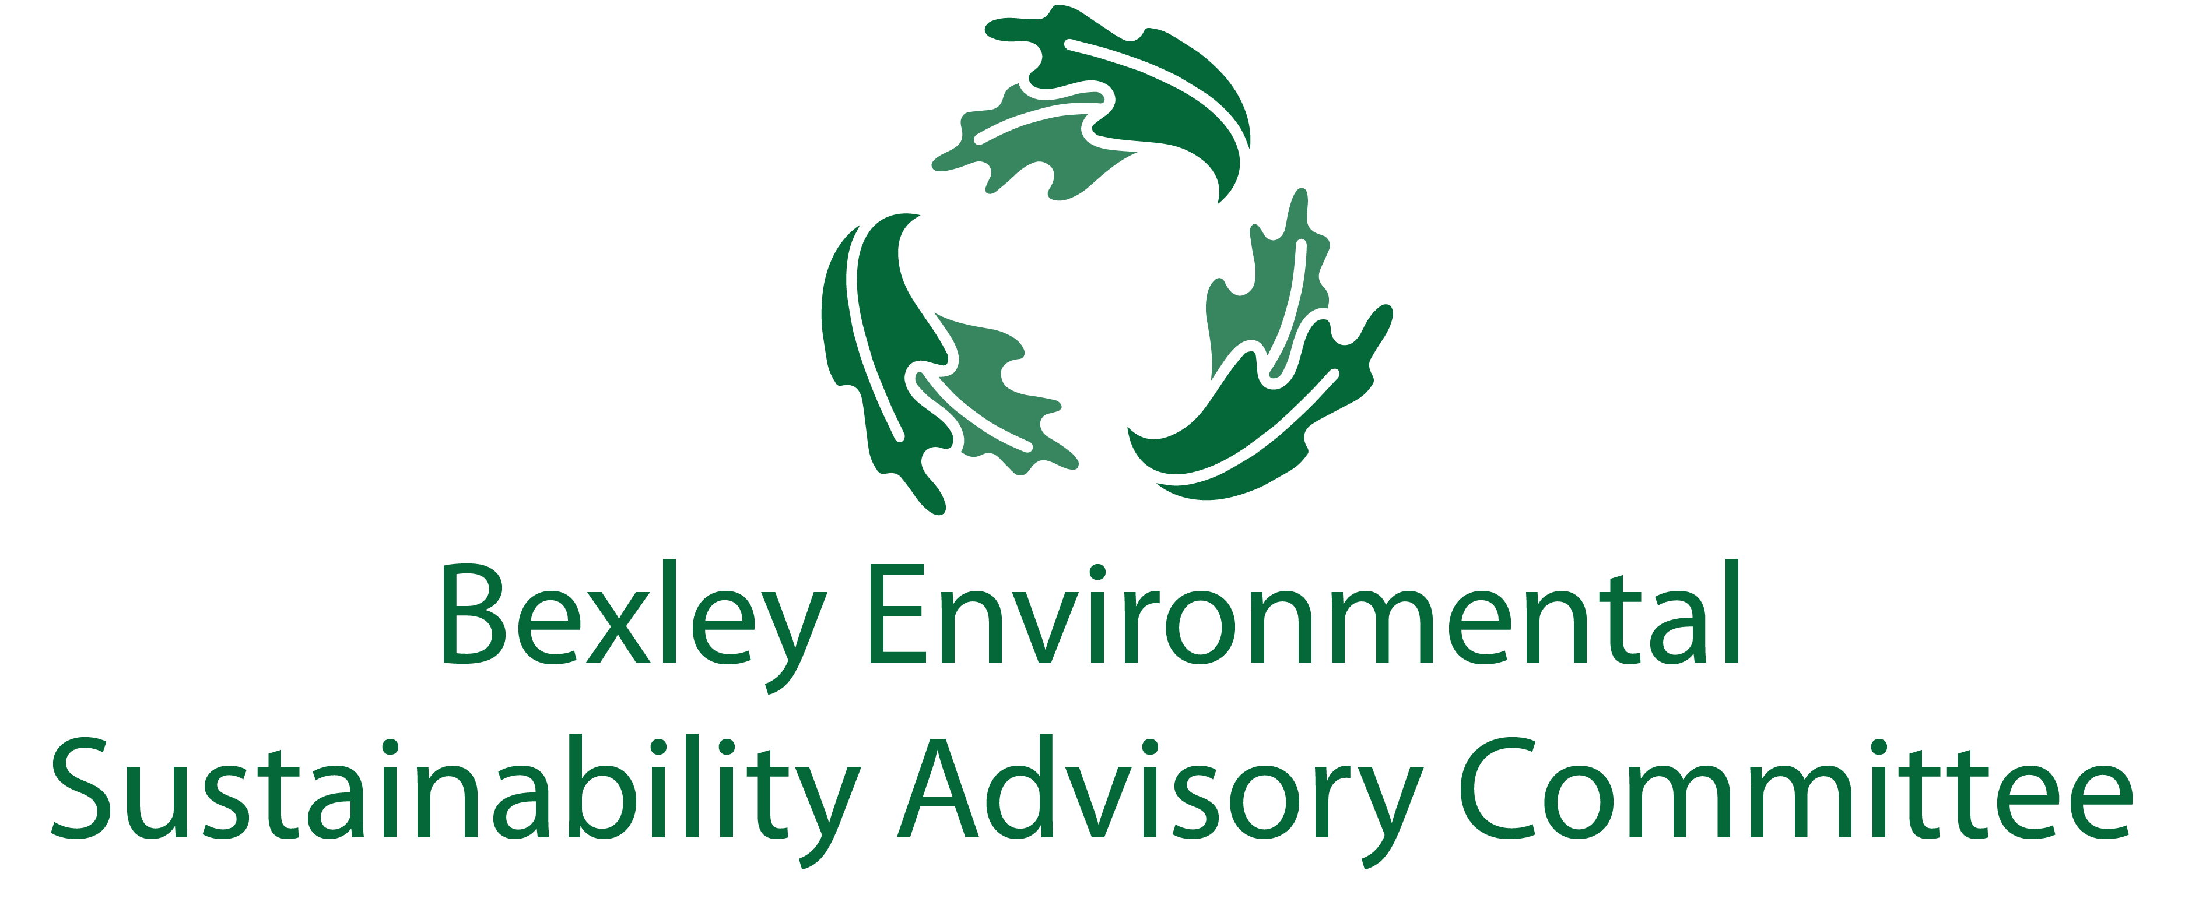
May 19, 2020
6:00 pm, the Comfort of Your Home
Meeting Agenda
- Roll Call & Introductions

- Major Goals Update
  - Single Use Plastic Bag Ban (Ben)
  - Food Waste Recycling Program (Elizabeth/Ben)
  - Communications and General Community Education Update (Elizabeth)
  - Universal Recycling (Elizabeth)
  - Drop-Off Facility (Elizabeth)
  - SUP Ban Update (Elizabeth/Ben)
  - Programming
    - Green Bexley Fair (Elizabeth)
    - Boot Camp
    - Seed Distribution (Rebecca)
    - Trash Pickup (Kathy)
    - NEW IDEA ALERT: Zoom Bootcamp Warm Up – “Lunch and Learn”/ “Make and Take”/ Virtual Green Drinks/ (Carol via Elizabeth)

- Other Updates
  - Chamber Update (Lesli)
  - Schools Update (Jen, John, Paul, Youting, Sophia)
  - The Bexley Bag (Ben)
  - ESAC Membership/ Structure (Elizabeth/Ben)
  - Bike Repairs and Donations Assistance (Ben)
  - Daycare (Midge)
  - GHG Goals (Carol)
  - MORPC Summit (Steve)
  - Residential PACE (Ben)

- Successes
  - COSI Big Science Celebration (Elizabeth)
  - Earth Day Art Walk (Rebecca)

- Free Thinking- Big Ideas Brainstorm Time
  - 4th of July
  - What do we want to do/see in year three?

- Announcements
  - Sunscreen

- Adjourn
  - Next meeting is June 16th at 6:00 pm.

