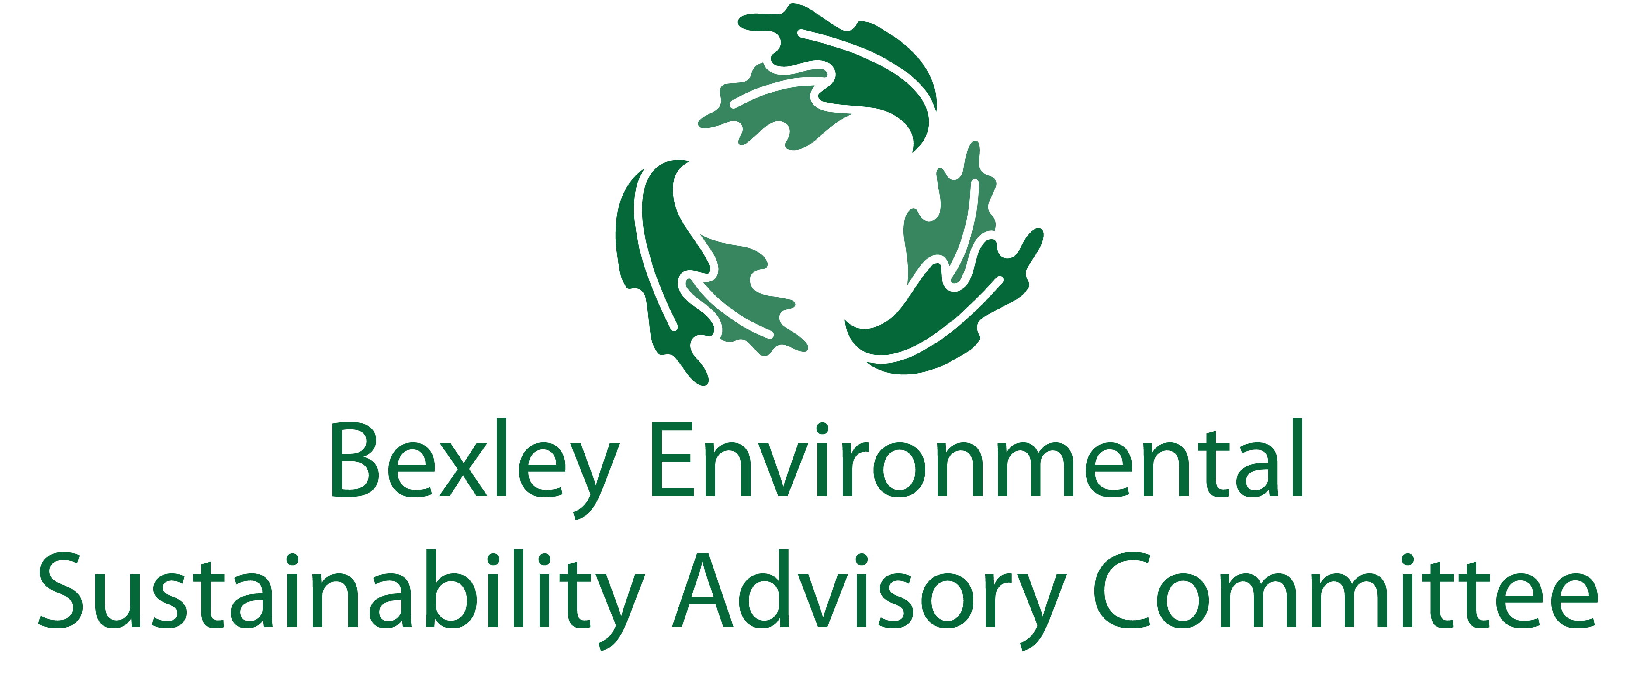
December 15, 2020
6:00 pm, the Comfort of Your Home
Meeting Agenda

Save time for announcements

- Roll
- Call & Introductions:
- Successes
  - Carol
- Major Goals Update
  - Communications and General Community Education Update (Elizabeth)
  - Food Waste Recycling Program (Steve/ Jo Anne)
  - Programming
    - The Great Green Bexley Independent Study Challenge (Elizabeth)
    - Kids’ Boot Camp (Rebecca)
  - Legislation and Lobbying (Kessler/ Richard)
  - Litter/Trail Clean Ups (Kathy and Addison)
  - Regional Forum (Steve)
  - DEI (Kathy/ Kokila/ Alina/ Carol?)
  - Love Your Alley (Rebecca/ Addison/ Midge/ Carol)
  - Water (Kathy with help from Carol)
  - Expansion (Kathy, Carol, Kokila, Elizabeth)
- Other Updates
  - Chamber Update (Lesli)
  - Schools Update (Jen, John, Paul, Kokila)
- Updates from Things off the Table:
  - GHG Goals (Carol)
  - Natives at schools (Rebecca)
  - Strategic Plan/ More Policy/ Carol’s Big Idea
  - Environmental Justice speaker (Kathy)
  - Grants
- Free Thinking- Big Ideas Brainstorm Time
  - Breakout rooms during meetings? Twice monthly meetings? Meetings offline?
  - 2021 ESAC Goals- What do we want to see happen? How can we make it happen?
- Announcements
  - OEC Environmental Trivia
  - Updated recycling
  - Light collection
  - Water info in Blast from FCSWD
- Adjourn

The Bexley community will significantly reduce its contribution to the landfill through sustainable initiatives for residents, businesses, institutions, and industries by improving public engagement, education, and infrastructure (ZWP 2-1)

The City of Bexley will accomplish the Zero Waste objective by 2040 or sooner when it achieves a 90% reduction of materials disposed at the landfill. The recommendations will be implemented in Phases and the ZWP will be updated by the City of Bexley Green Team every five years or earlier as determined by City Council (ZWP 1-6)

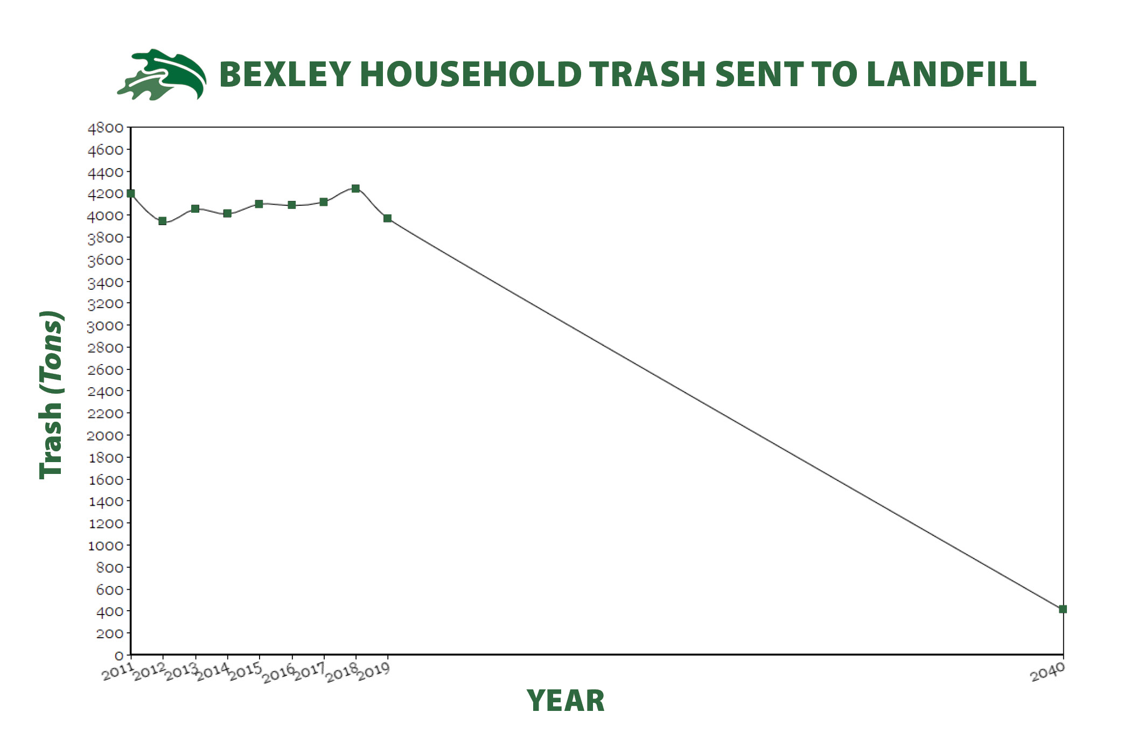

Note: Each sector also had its own list of objectives, which are typically to evaluate various things.

Green highlights are completed actions.
Red highlights are abandoned actions.

ZWP to be updated 5 years from 2017/2018, or sooner, as Council deems appropriate.

Recommended Actions for Residential Sector (3-21 and 3-22)

Phase 1 (2018-2023) | Phase 2 (2024-2030) | Phase 3 (2031-2040)
Toters for single family homes | MFH Recycling
Contract reviewed and pay-as-you-throw and semi or fully automatic collection explored | Contract reviewed and pay-as-you-throw and semi or fully automatic collection explored
Back yard composting encouraged | SWACO addressing hard-to-recycle materials (including plastics 3-7)
Yard waste collection at curb for those not interested in back yard composting
Composting pilot program for residents and businesses
Educational program emphasizing existing collection opportunities for HHW, electronics, textiles
Explore partnership with other communities for textile recycling
Reducing plastic bags
Electronics drop-off
Increase data collection to issue plan and complete studies
Eliminate backdoor service

Recommended Actions for Business Sector (4-19 and 4-20)

Phase 1 (2018-2023) | Phase 2 (2024-2030) | Phase 3 (2031-2040)
Get info re recycling for businesses | Establish Green Teams within commercial and Industrial business
Form stakeholder group to discuss topics | Develop business plan with tasks and dates for recycling
Implement mandatory recycling | Conduct general business-specific waste audits
Expand reuse and source reduction of waster materials within businesses | Implement special waste recycling and reuse programs to manage special wastes, including electronics
Develop short and long term business plans for commercial and industrial compost | Work with businesses to improve contracting, auditing and dumpster service
Conduct inventory of businesses to be targeted by compost program | Conduct selected waste audits for one or more targeted businesses
Require policy for pairing of trash and recycling containers | Revise long term plan if necessary based on pilot project results
Promote education and development of greater plastics recycling | Adopt policies promoting purchase of recycled-content, or environmentally sustainable products.
 | Establish specifications for all construction projects which require construction and demo debris to be reused or recycled
 | Develop communication plan as part of education program targeted at business owners and waste management programs.

Recommended Actions for Educational Sector (5-18 and 5-19)
Phase 1 (2018-2023) | Phase 2 (2024-2030) | Phase 3 (2031-2040)
Contracting, auditing, and dumpster service | Construction and demo debris
Purchase recycled-content products | Events
Waste sorts
Special Wastes
Reuse and waste reduction
Data collection
Communication Plan

Recommended Actions of City (5-26)
Phase 1 (2018-2023) | Phase 2 (2024-2030) | Phase 3 (2031-2040)
Create ESAC | Contracting, auditing, and dumpster service
Website | Construction/Demo policy
Recycling containers- consistency | Policy for purchasing recycled-content products
“Green” special events

Recommended Education and Promotion of ZWP (6-8)
Phase 1 (2018-2023) | Phase 2 (2024-2030) | Phase 3 (2031-2040)
Establish Education and Outreach Planning Subcommittee | Create education signs to brand ZWP for high traffic areas
Develop schedule to present ZWP to community | Provide businesses that recycle a sign to advertise
Develop specific plan for informing residents about new programming
Work with BCS to schedule professionals to educate students and faculty
Work with Capital Sustainability Council establish data needs and working relationship with City
Coordinate with IT for social media material
Web based directory
Create list of local haulers for commercial sector have this listed online
Map out Drop-off recycle locations within 2 mile radius

