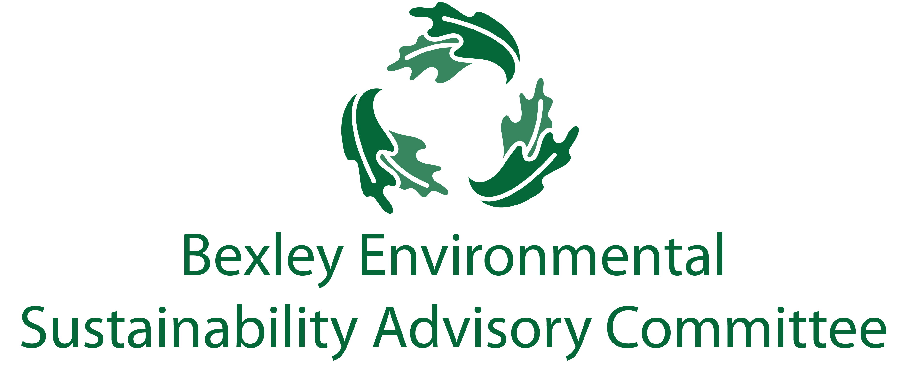
February 18, 2020
6:00 pm, Bexley City Hall
Meeting Agenda
- Roll Call & Introductions

- Current Events and Special Visitors
  - Cathy Cowan Becker (Ready for 100 Columbus)
  - OEC Representative

- Getting Stuff Done Updates
  - Green Bexley Fair (Elizabeth)
    - Overview of event
    - Who is doing what
    - What needs to be doing what

- Major Goals Update
  - OSU Student Studies (Elizabeth/Ben)
    - Universal Recycling
    - Drop-Off Facility
  - Single Use Plastic Bag Ban (Ben)
  - Food Waste Recycling Program (Elizabeth/Ben)
  - Communications and General Community Education Update (Elizabeth)
  - Chamber update (Lesli)
  - Schools (Jen, John, Paul, Youting, Sophia)

- Other Updates
  - Programming
    - Wasted (Kathy)
    - COSI Big Science Celebration May 9, 2020 (Elizabeth)
    - Green Drinks (Kathy)
    - Residential PACE (Ben)
  - The Bexley Bag (Ben)
  - ESAC Membership/ Structure (Elizabeth)
  - Bike Repairs and Donations Assistance (Ben)
  - Daycare (Midge)
  - GHG Goals (Carol)

- Successes

- Free Thinking- Big Ideas Brainstorm Time

- Announcements
- Adjourn
  - Next meeting is March 17th at 6:00 pm.

