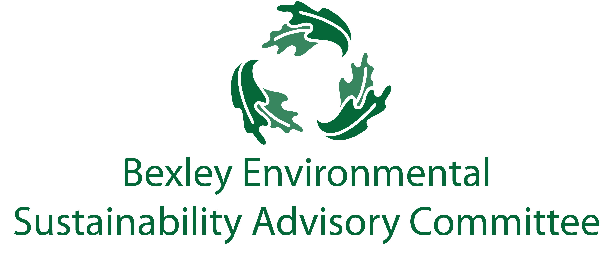
April 16, 2019
6:00 pm, Bexley City Hall
Meeting Agenda
- Roll Call & Introductions

- Current Events

- Major Goals Update
  - Plastic Bag Ban (Troy)
  - Food Waste Recycling Program
  - Sustainability Fair/ Week (Kathy, Carol, Rebecca, Elizabeth)
  - Communications and General Community Education Update (Elizabeth)
  - Drop off Bins update (Elizabeth)
  - Chamber update (Lesli)
  - School Committee (Jim, Paul)
  - Badges/seal for businesses (Lesli, Joanna)

- Successes

- Free Thinking- Big Ideas Brainstorm Time

- Announcements

- Adjourn
  - Next meeting is May 21 at 6:00 pm.

