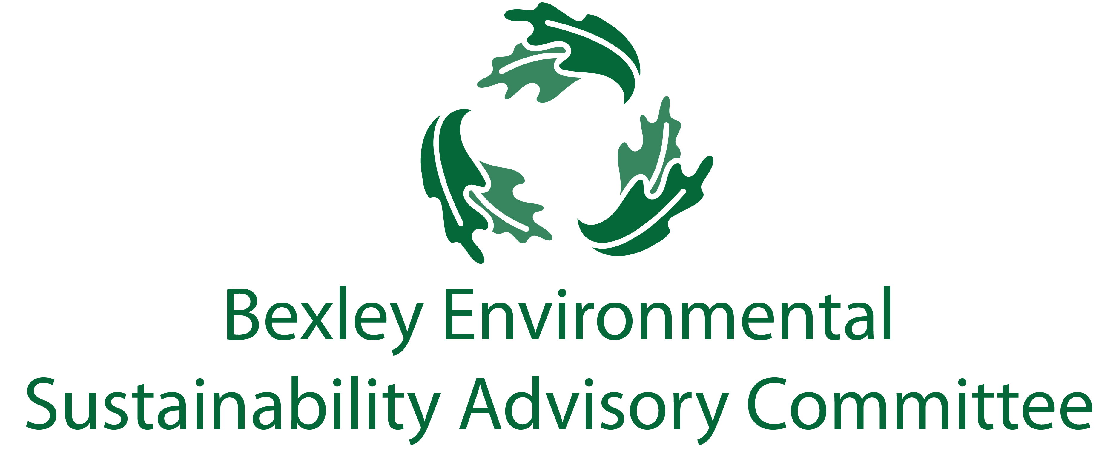
February 26, 2019
6:00 pm, Bexley City Hall
Meeting Agenda
- Roll Call & Introductions
- Current Events

- Guest- Kyle O’Keefe, SWACO Director of Innovation and Programs

- Major Goals Update
  - Plastic Bag / Single Use Plastic Ordinance – Troy
  - Community education regarding plastic bag use – Jo Anne and Troy
  - Food Waste Recycling program update & next steps / ESAC involvement
  - Food waste recycling community outreach - Joanna and Jo Anne
  - Sustainability Week (April 22nd- April 27th) – Kathy, Carol, Rebecca, Elizabeth
  - Communications update – Elizabeth
  - General Community Education- Elizabeth
  - Drop off Bins- Elizabeth
  - SWACO Community Waste Reduction Grant- Steve
  - Chamber update – Lesli Mautz
  - School Committee- Jim, Paul
  - Mandatory Commercial and MF Recycling- Carol, Ben
  - PACE promotion- Drew, Steve, Ben
  - Badges/seal for businesses- Lesli, Joanna

- New Members

- Successes

- Free Thinking – Big Ideas Brainstorm Time
- Adjourn
  - Next meeting is March 19 at 6:00 pm

