Board of Zoning and Planning Meeting of June 24, 2021

**Staff Report**

Kathy Rose

**Old Business**

1. Application Number: BZAP-21-7

Address: 2534 Brentwood

Applicant: Valerie Kieffer

Owner: Valerie Kieffer and Hoover Myles

Request: Variance to allow a swim spa in the rear yard less than 8’ from the side property line. Also a variance to allow a 6’ fence in the east side yard along Cassingham Road

If you recall this applicant was before the Board seeking a variance from Bexley Code Section 1252.15, which requires accessory structures to be located in the rear yard, to allow a proposed swim/spa in the west side yard. There was concerns from the neighbor to the west about the noise at that time. The applicant tabled the application and has returned with a new plan that locates the swim/spa in the rear yard and on the east side of the lot. The applicant is now seeking a variance from Bexley Code Section 1252.10(2) which requires accessory structures to be located 5’ further back from the side street property line than the principal structure. Lots 50’- 100’ require a 20’ setback. The applicant would like to place the swim/spa 9’6” from the east side property line.

The applicant is also seeking a Special Permit in accordance with Bexley code Section 1264.03(b) which states No fence, wall or combination thereof shall exceed forty-eight inches in height in the side yard setback area as it faces a public or private street……Fencing or walls exceeding forty-eight inches in height, as measured from the average grade, may be allowed with a special permit from the Board of Zoning and Planning. The Board shall consider the following criteria in reviewing such applications:

1. Fence is compatible with other properties in the neighborhood.
2. Maximum height not to exceed 72” - Met
3. Fences exceeding forty-eight inches in height should include transparency in the upper 12" to 18" of the fence through the use of latticework, pickets, or other appropriate design elements.- Provided

      (4)    A landscaping plan must be filed with the application for a fence permit and approved by the Zoning Officer, indicating how such fencing or wall is to be screened from the street side elevation. The landscape plan should be designed in such a way as to mitigate the impact of a solid fence or wall as it relates to the street and other properties. - Provided

      (5)    The installation of such fence or wall shall not create a visibility or safety concern for vehicular and/or pedestrian movement. - Staff has suggested that the fence be angled at the alley where it meets the street. The applicant has provided that modification.

      (6)   No chain link, wire mesh or other similar material shall be installed on lot lines adjacent to public rights-of-way.- This is a wooden fence

1. Application Number: BZAP-21-19 Address: 2455 E. Main Street

Applicant: Chris Vallette

Owner: Mattlin Holdings LLC

Request: The work is to add a 1,300 sq. ft. manufactured awning over and existing 1,516 sq. ft. restaurant outdoor patio area.

**Staff Report from Jason Sudy and ARB update from Karen Bokor**

**New Business**

1. Application Number: BZAP-21-20

Address: 2753 Sherwood Road

Applicant: Jarrett Fuller

Owner: Matthew and Kathleen Borges

Request: Porch addition to garage.

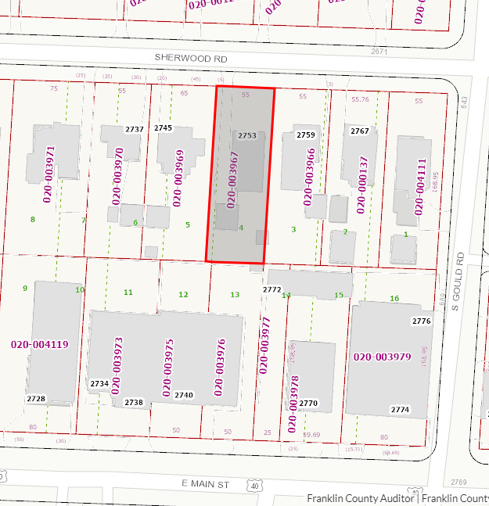

The applicant is seeking a 96sq’ variance from Bexley code Section 1252.15 which limits an accessory structure to 624sq’ for lots that are 6,000 to 13,900 square feet, to allow a 240 square foot porch addition to the rear of the existing 480sq’ garage for a total of 720sq’.

This property is located in the R-6 Zoning District which allows 35% for total building footprint and 60% overall (building plus hardscape). With the proposed addition to the garage this lot will have 24% building footprint and 48% overall, which meets code.

The primary use of the structure is for parking; however, the applicant would like the added porch to provide a flex space for yoga, but anything more than personal use would require a Home Occupation which is typically limited to the principal structure, being this was mentioned at the ARB meeting I thought that should be on the record.

1. Application Number: BZAP-21-24

Address: 2115 Clifton Applicant: Meryl Neiman Owner: Meryl Neiman

Request: Lot coverage variance to replace & expand deck. 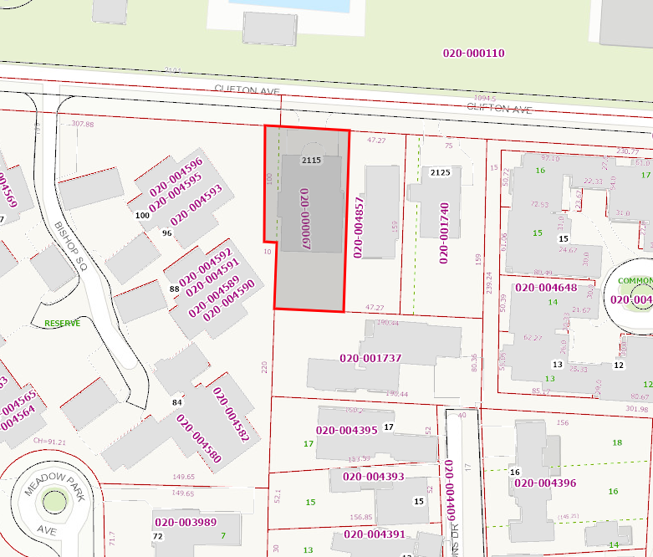

The applicant is seeking a variance from Bexley Code Section 1252.09 R-3 Zoning District, which limits building footprint to 25% and overall lot coverage (building and Hardscape) to 50%. The existing lot is 11,657 sq’ which non-conforming in comparison to the standard 14, 400 sq’ minimum lot size.

The home is currently 381sq’ over the building lot coverage limit of 25%. They would like to add a 132 square foot extension to the existing rear deck, along with hardscape and landscape improvements. The proposed improvements will remain under the overall lot coverage limit by 5%, but will exceeds the building footprint limit by 4%.

I’d like to point out that this property is surrounded by other lots similar in size, some of those being part of Planned Unit Developments such as Sessions Village, Bishop Square and Lyonsgate, which typically have greater lot coverage limits. The proposed plan would not be out of character for the neighborhood in which it is located.

1. Application Number: BZAP-21-27

Address: 2713 Bryden Road

Applicant: Amy Lauerhass

Owner: Steven and Danielle Dankof

Request: variance to allow 2-1/2 car detached garage to be 9’ from the house.

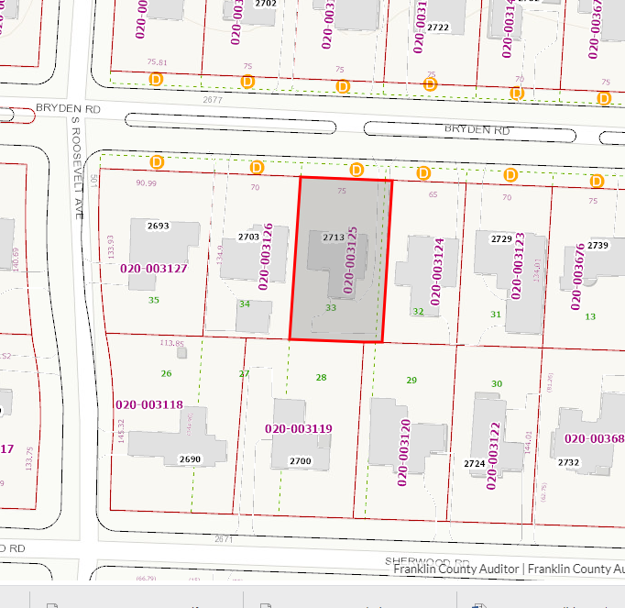

The applicant is seeking a 1’ variance from Bexley Code Section 1252.15, which states that a detached garage shall not be located less than ten feet from a principal structure, to allow the proposed garage to be located 9’ from the principal structure.

This garage was previously approved on April 8, 2021 for design and location under ARB-21-29. At that time, it met all current zoning regulation. It was later determined that a city utility easement is located at the rear of the property. In order to locate the garage outside the easement it would be necessary to move the garage closer to the principal structure. The would place the garage 9’ from the principal structure. Therefore, the applicant filed a variance request to address the change in setback.

**OTHER BUSINESS**:

2691 E. Main Street

Inquiry on front yard modifications as opposed to repair/replace.

