

Bexley Board of Zoning and Planning

Staff Report – October 28, 2021

By Kathy Rose, Zoning Officer

**OLD Business:**

**a. 276 S. Stanwood – variance from setback to rear property line**

**Application** **Number:** BZAP-21-42

**Applicant**: Joseph Carifa

**Owner**: Katherine Moss and Simon Doolittle

**Location**: 276 S. Stanwood

**Zoning**: Medium-High Density Single-Family Residential District (R-6)

**Request:** The applicant is seeking Architectural Review and approval to allow a new deck to replace an existing elevated Patio. The applicant is also seeking a variance from Bexley Code Section 1252.11(c)which allows an uncovered deck to encroach 4’ into the 25’ rear yard setback in accordance with Bexley Code Section 1252.09(R-6) zoning. If approved, the deck would be 15.5’ from the rear property line. (the existing elevated patio is 18.5’ from the existing rear property line.)

**SITE CONSIDERATION**

The existing principal structure is non-conforming in that it is located 15’5” from the rear property line.

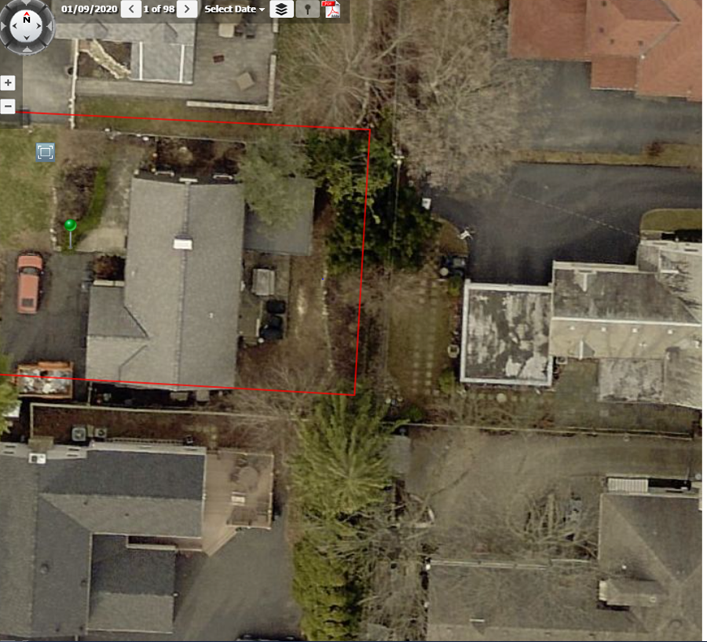

A 25’ setback from the rear property line is required for enclosed living space.

A deck, if uncovered, may encroach 4’ into the rear yard setback. Which would be 21’.

The existing patio is approximately 11’6” x 16’ and 2’ above grade. It does not extend as far to the rear of the lot as the enclosed living space.

The condition of the side walls of the elevated patio appear to have some patched and repaired areas, which may be the reason they wish to remove the structure.

The new deck is proposed at the same level, but will extended to be in line with the rear wall of the principal structure.

The ARB did review, and found that should the Board find it appropriate to grant a variance, it should also include a 6’ fence along the rear property line that will be installed simultaneously with the new deck.

**b. 2450 E. Livingston – Special Permit for fence height**

App: BZAP-21-39

Applicant: Michael Grimm

Address: 2450 E. Livingston

Request: The applicant is seeking a special permit in accordance with Bexley Code Section 1264.03(b) which limits fences to forty-eight inches in height in the side yard setback area as it faces a public or private street, to allow a 3.5’ high retaining wall with a 4’ fence on top, for a distance of 43’ along the west side property line along Montrose Avenue.

**Background**

This property is located at the north east corner of E. Livingston Avenue and Montrose Avenue.

There is a 6’ fence located 10’ behind the city sidewalk along Montrose Avenue. There is also a ____ change in elevation between the existing fence and city sidewalk.

The applicant is trying to expand the rear yard space and also screen the set of large windows on the west side of the house, by adding a retaining wall at the property line, which is approximately 3.5’ behind the city sidewalk and filling in behind the retaining wall level with the rear yard.

I find the overall height to be excessive, at 7.5’ and have asked the applicant to show the setback between the proposed retaining wall and 4’ fence. It could help if they are offset, but it could also look excessive.

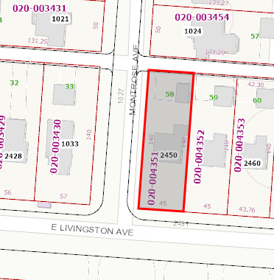

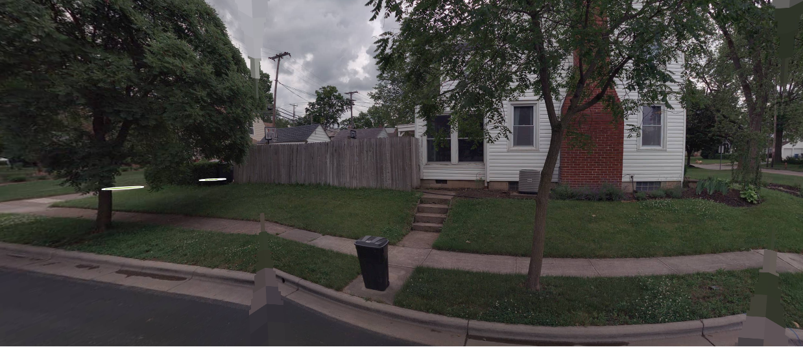

Bexley code Section 1264.03(b) which states No fence, wall or combination thereof shall exceed forty-eight inches in height in the side yard setback area as it faces a public or private street……Fencing or walls exceeding forty-eight inches in height, as measured from the average grade, may be allowed with a special permit from the Board of Zoning and Planning. The Board shall consider the following criteria in reviewing such applications:

1. Fence is compatible with other properties in the neighborhood. This property backs up to other front yards along Montrose
2. Maximum height not to exceed 72” – Fence and retaining wall is 7.5’
3. Fences exceeding forty-eight inches in height should include transparency in the upper 12" to 18" of the fence through the use of latticework, pickets, or other appropriate design elements.- Original submittal did not

      (4)    A landscaping plan must be filed with the application for a fence permit and approved by the Zoning Officer, indicating how such fencing or wall is to be screened from the street side elevation. The landscape plan should be designed in such a way as to mitigate the impact of a solid fence or wall as it relates to the street and other properties. – The species of plants are not indicated.

      (5)    The installation of such fence or wall shall not create a visibility or safety concern for vehicular and/or pedestrian movement. – The fence is not to be located near the alley along the north rear property line.

      (6)   No chain link, wire mesh or other similar material shall be installed on lot lines adjacent to public rights-of-way.- This is a wooden fence

If the Board finds it appropriate to grant a special permit, it should be conditioned upon a specific distance between the retaining wall and fence, and a landscape plan approved by the city landscape consultant.

NEW Business:

**c. 280 S. Columbia – variance for pool and pool house in side yard**

Application Number: BZAP-21-44

Applicant/Owner: Corey Tishkoff

Location: 280 S. Columbia

Request: The applicant is seeking Architectural Review and approval of a pool house . The applicant is also seeking a variance from Bexley Code Section 1252.16(g)(a) Accessory structures and uses shall be permitted only in the rear yard ……., to allow a proposed pool and pool house to be located in the north side yard at this location.

Background

This lot is 141’ wide by 250’ deep and the house sits back on the lot and has a detached garage at the rear. The back of the lot has a substantial change in grade, making the north side of the lot a more ideal location for a pool.

Code requires a pool to be setback 8’ from a side or rear property line. The lot is wide enough to allow the pool deck to be approximately 17’ from the north side property line, and the pool to be approximately 27’ from the north side property line.

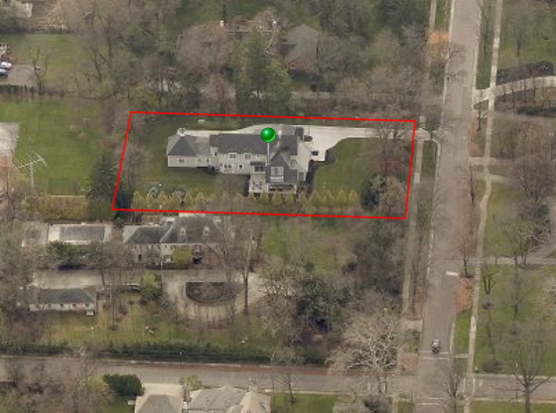

With the location of the attached garage at the east end of the house, it makes more sense to locate the pool in the side yard of this 141’ wide lot. Staff also finds that the side yard location provides the ability to set it further from the neighboring property and will be nest to an existing landscape buffer located just north of the north side property line.

The design concept of the pool house was shared with the Architectural Review Board, however we did not have specific details and the Architectural Review Board asked that the final design details return to them. The size of the structure is not a concern, but it also required a variance based on the fact that it is also located in the side yard.

If the Board finds granting a variance to be appropriate, Staff would also ask that the balance of the landscape be subject to the design consultant or T&PGC.

**d. 2831 E. Broad – variance to 25’ rear yard setback**

Application No. BZAP-21-46

Applicant: Gary Alexander

Owner: Kimberly Demond

Location 2831 E. Broad Street

Request: The applicant is seeking architectural review to allow the existing garage to be converted to living space, add a roof over the rear patio and an attached garage. The applicant is also seeking a variance rom Bexley code Section 1252.09(R-6) which requires a rear yard setback of 25’ and a side yard setback of 8’, to allow a portion of the proposed garage addition to encroach 7’7” into the 25’ rear yard setback and 8.5” into the side yard setback.

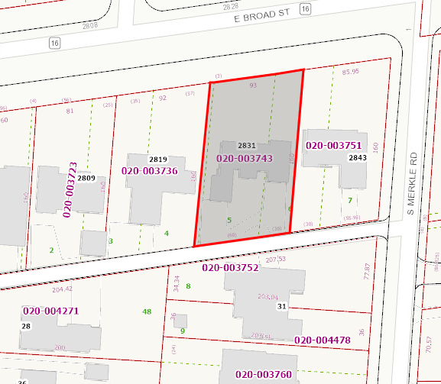

Background

The lots along the south side of Broad street between S. Roosevelt and S. Merkle have a slight angle to the front and rear lot lines and why only a portion of the proposed garage addition would encroach into the rear yard setback. The southwest corner of the garage addition would be 24’ 3” from the rear property line and the southeast corner of the proposed garage would be 17’5” from the rear property line.

The house to the west has a similar situation and if the owner proposed a detached garage, it could be 3’ off the alley. The current proposed plan still allows for additional parking in the rear as proposed and keep cars off of the side streets.

**e. 81 N. Drexel – variance for pool and pool house in west end of front yard**

Application No. BZAP-21-47

Applicant: Keith Witt

Owner: Consecutive Prime, LLC

Location: 81 N. Drexel

Request:

The applicant is seeking Architectural Review and approval of a pool house. The applicant is also seeking Special Permit in accordance with Bexley code Section 1252.12(a)(b), where the principal structure deviates by more than twenty percent from the established front yard setback line, to allow a swimming pool and pool house at the western end of the front yard at this location.

This is a large lot that is 300’ wide (along Clifton Avenue) and 200’ along Drexel Avenue.

The Clifton Avenue side of the property has been determined as the front yard.

The house sits to the north end of the lot with a setback of approximately 110’ from the Clifton Avenue property line. The driveway runs along the north end of the property, leaving limited space for anything improvements in the rear yard.

The only other house on that north side of this block sits back approximately 60’, making the average setback off of the Clifton Avenue to be 85’

The applicant has proposed the 16’ x 50’ swimming pool within a sunken terrace that will be located off the west end of the front façade, and a proposed pool pavilion just to the south end of the pool terrace. The south end of the pool pavilion is 43’ from the south (front) property line and 15’ from the west side property line.

A 15’ side yard setback is what is typically required for a principal structure as accessory structures can be located 3’ off of a side or rear property line; however, a swimming pool is an exception and requires an additional 5’ for an 8’ setback. The pool terrace and pool equipment meet the 8’ setback and will be screened and fenced.

Bexley Code Section 1264.02 – Limits fences to 42” in height in the front yard with a Special Permit from the BZAP

There is an existing 6’ wrought iron fence located in the front yard, that the applicant is requesting to replace it with a 48” high fence (minimum required to enclose a pool) and also landscaping.

If the Board finds it appropriate to grant a variance, it should be subject to landscape review by the tree & Public Garden Commission to make sure there is sufficient screening along the west property lien, of the pool equipment.

final review

Prepared by:

Kathy Rose

Zoning Officer