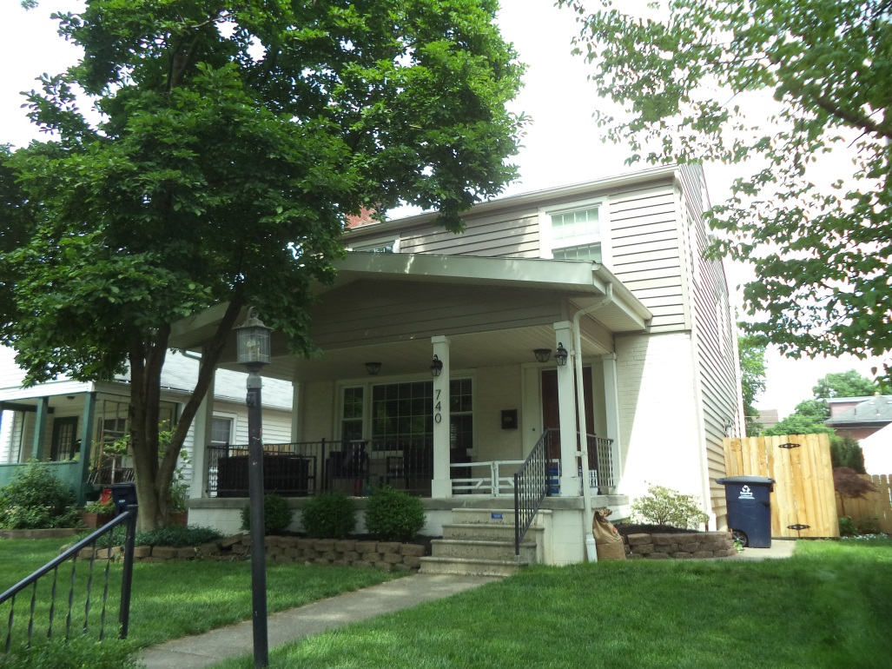 | 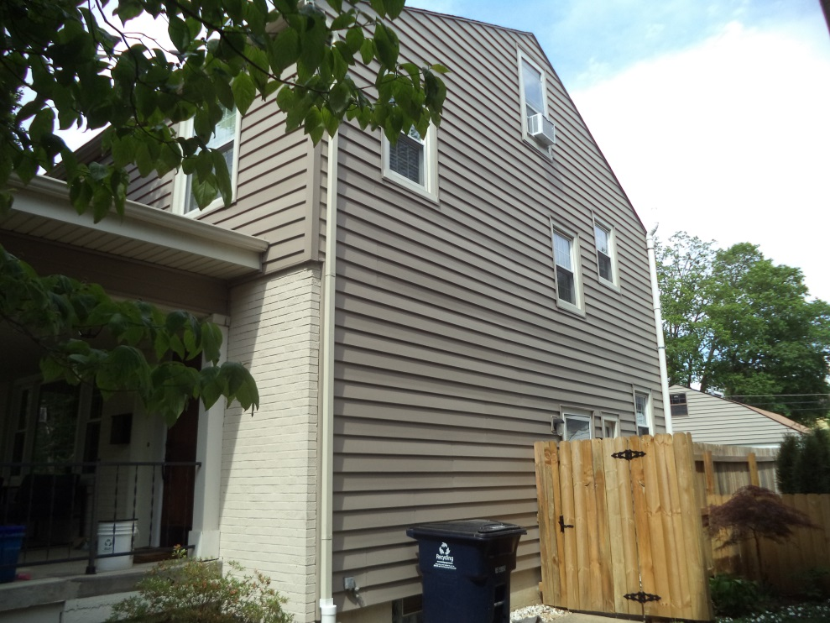
FRONT OF HOUSE | RIGHT SIDE VIEW
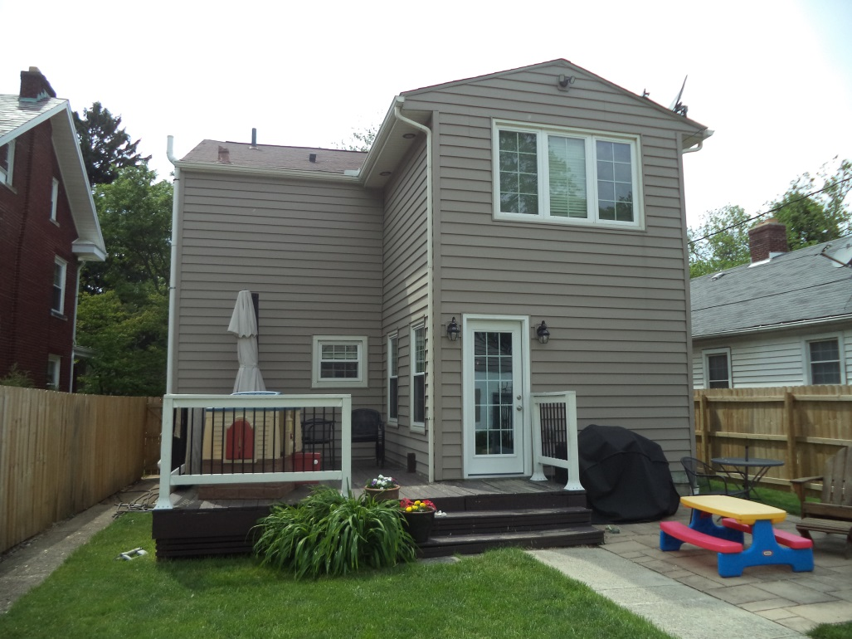 | 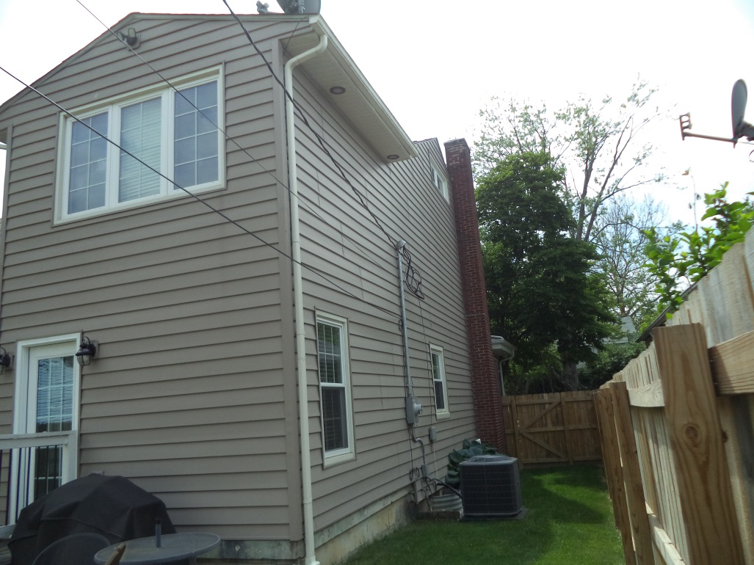
REAR OF HOUSE | LEFT SIDE VIEW
740 EUCLAIRE AVENUE

