January 22, 2025 – 1:00 p.m.

Buying Back the Land for the Sake of Community

Learn about the history and the evolving mission of the Arc of Appalachia, over 12,000 acres of the most intact wildlands remaining in Appalachia. Long time volunteers and supporters Kevin Eigel, Marcia Miller, and Stan Sells will take you on a thought-provoking journey through this area and share stories of the region and what makes this land so special. You’ll learn about the Arc’s mission and the people who have worked hard to make certain this very special area is preserved and continues to grow.

https://www.arcofappalachia.org/

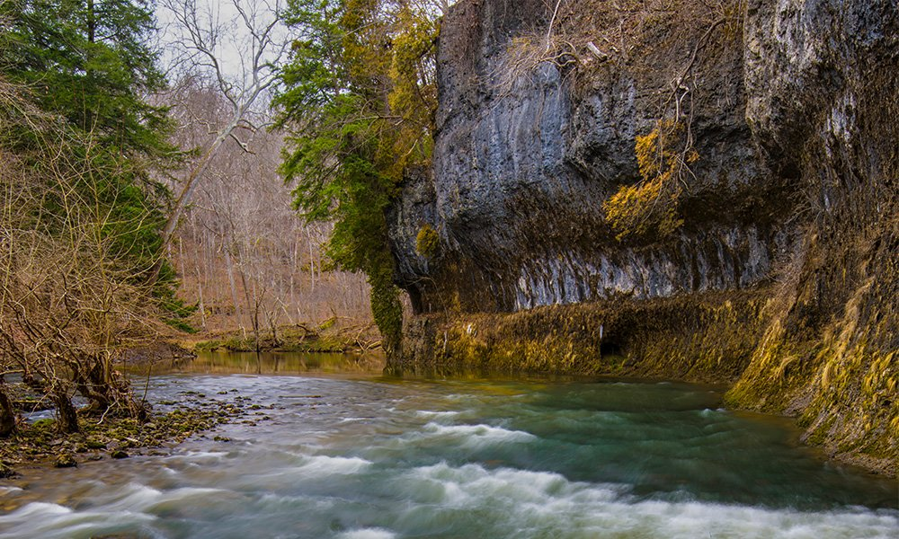

Wednesday February 12, 2025

Belinda Gore – Founder, The Great Circle Alliance

Learn more about the first and only UNESCO World Heritage site located here in Ohio – the Hopewell Ceremonial Earthworks. Spanning several locations throughout Ohio and built by American Indian communities, these earthworks served as sacred gathering places. Upon discovering they are some of the largest and most complex in the world, Belinda Gore began her quest to learn more. In 2021, she and Marcus Boroughs founded The Great Circle Alliance, a nonprofit organization whose mission is to offer public programs and exhibits to raise awareness of the ancient monumental indigenous sites of Ohio. Their work includes a residency for contemporary Native artists to bring an indigenous presence back to the once vibrant sophisticated culture 2,000 years ago.

[https://belindagore.com/biography/](about:blank)

[https://hopewellearthworks.org/](about:blank)

