

February 22, 2022

6:00 pm, your house

Meeting Agenda

Zoom Link:

<https://us02web.zoom.us/j/83230101467?pwd=aFVqM3dCcXJNaVlkS3FySVowZkhHZz09>

1. Roll Call & Introductions: Steve, Ashley, Kathy, Lesli, Elizabeth, Jeremy
2. Major Goals Update

* 1. ESAC reorganization (Rebecca) – Kathy is leaning towards alternating leadership beween meetings; Kathy will speak with Rebecca
  2. Redefining ESAC
  3. Food Waste Recycling Program (Steve/ Jo Anne)
     1. Current Sign Ups: 1688 ~ 38-40%
     2. Participating households: 1300-1400
     3. Steve and Jo Anne will begin walking again in South Bexley
        1. Homes that Steve and Jo Anne have dropped literature at are about 50% more likely to participate
  4. Litter/Trail Clean Ups (Kathy and Addison) – Pickups are scheduled for 3/26, 4/9, 4-16, 4-22, 4-30
  5. Mosquito Spraying (Rebecca)
     1. To take place this summer
     2. Still looking for groups of households
  6. Climate Action Plan (Carol, Drew, Rob, Kessler, Elizabeth)
  7. Bike Friendly Bexley
  8. Forum (Steve) – It was excellent!
     1. First in-person gathering of resident environmental sustainability groups
     2. ~10 groups were represented; 35 people were there
  9. LYA (Rebecca)
     1. Looking for an alley to be in the House and Garden Tour.
     2. Love Your Alley Festival on May 14
  10. Yes You Can (Rebecca)
      1. Stickers are available to place on your trash can
  11. Sustainability Programs Coordinator (Elizabeth)
      1. “Green Bexley” – Elizabeth will use this term too, so all of the outward facing programs/events/activities will be “Green Bexley” regardless of whether they come from the ESAC or City’s Sustainability Department. This also makes her feel better being the one running the website and social media with the “Green Bexley” brand.
      2. Seed exchange – no one wants to take this on as a stand-alone program, but maybe it can be part of the ESAC table at the Fair or at the Farmer’s Market
      3. COSI SciFest – Elizabeth will have a booth about plastic bags and DIYing a t-shirt bag.
      4. Newsletter – There’s a lot of eco-information at greenbexley.org/newsletter
      5. Feet on the Street – Elizabeth presented to Council; Kessler will help her get them on board. She should hear about the grant in a few months.
      6. Green Business Recognition Program – could be recreated in Bexley.
      7. Earth Month Website – it’s live at greenbexley.org/earthmonth. Please share to help promote!
      8. We will need volunteers to help at the Fair April 23 from 11-2 – an ESAC table and waste monitors (hopefully BHS or Capital students will be interested in monitoring the waste). Sign up at <https://bit.ly/greenbexleyfair22>.
      9. Clean-Up Day is on April 30. Please sign up to volunteer at [bit.ly/gbcud22.](https://bit.ly/gbcud22)
      10. Elizabeth would like to have a blog post a day from residents/community members throughout April. Please let her know if you’d be interested in contributing ASAP – she’ll need to have a few posts lined up before April 1.
      11. Elizabeth and the Mayor will be having upcoming meetings with George re: compost contract and Rumpke re: Universal Recycling.

1. Other Updates
   1. Chamber Update (Lesli) – no update
   2. Schools Update (Jen, John, Midge, Ashley)
      1. Capital is working on putting compost and recycling into various locations
2. Updates from Things off the Table
3. Successes
   1. Forum
   2. Yes You Can
4. Announcements
5. Free Thinking- Big Ideas Brainstorm Time
6. Adjourn

The Bexley community will significantly reduce its contribution to the landfill through sustainable initiatives for residents, businesses, institutions, and industries by improving public engagement, education, and infrastructure (ZWP 2-1)

**The City of Bexley will accomplish the Zero Waste objective by 2040 or sooner when it achieves a 90% reduction of materials disposed at the landfill.** The recommendations will be implemented in Phases and the ZWP will be updated by the City of Bexley Green Team every five years or earlier as determined by City Council (ZWP 1-6)

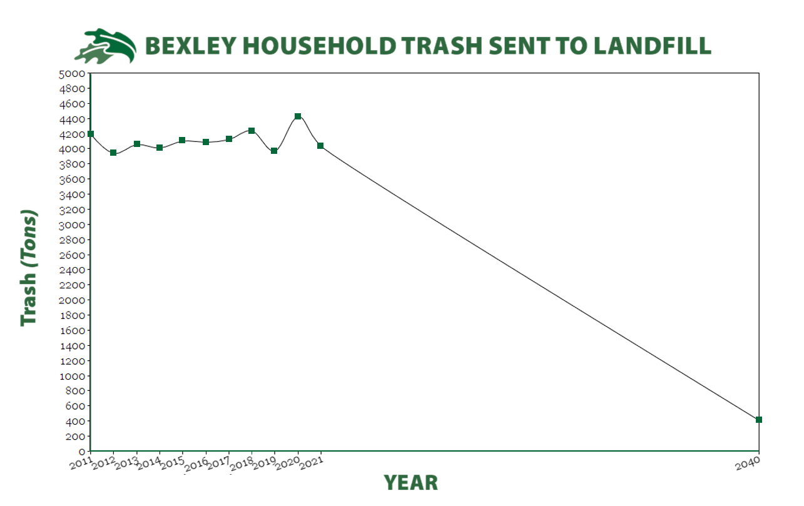

Note: Each sector also had its own list of objectives, which are typically to evaluate various things.

Green highlights are completed actions.

Red highlights are abandoned actions.

ZWP to be updated 5 years from 2017/2018, or sooner, as Council deems appropriate.

Recommended Actions for Residential Sector (3-21 and 3-22)

|  |  |  |
| --- | --- | --- |
| Phase 1 (2018-2023) | Phase 2 (2024-2030) | Phase 3 (2031-2040) |
| Toters for single family homes | MFH Recycling |  |
| Contract reviewed and pay-as-you-throw and semi or fully automatic collection explored | Contract reviewed and pay-as-you-throw and semi or fully automatic collection explored |  |
| Back yard composting encouraged | SWACO addressing hard-to-recycle materials (including plastics 3-7) |  |
| Yard waste collection at curb for those not interested in back yard composting |  |  |
| Composting pilot program for residents and businesses |  |  |
| Educational program emphasizing existing collection opportunities for HHW, electronics, textiles |  |  |
| Explore partnership with other communities for textile recycling |  |  |
| Reducing plastic bags |  |  |
| Electronics drop-off |  |  |
| Increase data collection to issue plan and complete studies |  |  |
| Eliminate backdoor service |  |  |

Recommended Actions for Business Sector (4-19 and 4-20)

|  |  |  |
| --- | --- | --- |
| Phase 1 (2018-2023) | Phase 2 (2024-2030) | Phase 3 (2031-2040) |
| Get info re recycling for businesses | Establish Green Teams within commercial and Industrial business |  |
| Form stakeholder group to discuss topics | Develop business plan with tasks and dates for recycling |  |
| Implement mandatory recycling | Conduct general business-specific waste audits |  |
| Expand reuse and source reduction of waste materials within businesses | Implement special waste recycling and reuse programs to manage special wastes, including electronics |  |
| Develop short and long term business plans for commercial and industrial compost | Work with businesses to improve contracting, auditing and dumpster service |  |
| Conduct inventory of businesses to be targeted by compost program | Conduct selected waste audits for one or more targeted businesses |  |
| Require policy for pairing of trash and recycling containers | Revise long term plan if necessary based on pilot project results |  |
| Promote education and development of greater plastics recycling | Adopt policies promoting purchase of recycled-content, or environmentally sustainable products. |  |
|  | Establish specifications for all construction projects which require construction and demo debris to be reused or recycled |  |
|  | Develop communication plan as part of education program targeted at business owners and waste management programs. |  |

Recommended Actions for Educational Sector (5-18 and 5-19)

|  |  |  |
| --- | --- | --- |
| Phase 1 (2018-2023) | Phase 2 (2024-2030) | Phase 3 (2031-2040) |
| Contracting, auditing, and dumpster service | Construction and demo debris |  |
| Purchase recycled-content products | Events |  |
| Waste sorts |  |  |
| Special Wastes |  |  |
| Reuse and waste reduction |  |  |
| Data collection |  |  |
| Communication Plan |  |  |

Recommended Actions of City (5-26)

|  |  |  |
| --- | --- | --- |
| Phase 1 (2018-2023) | Phase 2 (2024-2030) | Phase 3 (2031-2040) |
| Create ESAC | Contracting, auditing, and dumpster service |  |
| Website | Construction/Demo policy |  |
| Recycling containers- consistency | Policy for purchasing recycled-content products |  |
| “Green” special events |  |  |

Recommended Education and Promotion of ZWP (6-8)

|  |  |  |
| --- | --- | --- |
| Phase 1 (2018-2023) | Phase 2 (2024-2030) | Phase 3 (2031-2040) |
| Establish Education and Outreach Planning Subcommittee | Create education signs to brand ZWP for high traffic areas |  |
| Develop schedule to present ZWP to community | Provide businesses that recycle a sign to advertise |  |
| Develop specific plan for informing residents about new programming |  |  |
| Work with BCS to schedule professionals to educate students and faculty |  |  |
| Work with Capital Sustainability Council establish data needs and working relationship with City |  |  |
| Coordinate with IT for social media material |  |  |
| Web based directory |  |  |
| Create list of local haulers for commercial sector have this listed online |  |  |
| Map out Drop-off recycle locations within 2 mile radius |  |  |