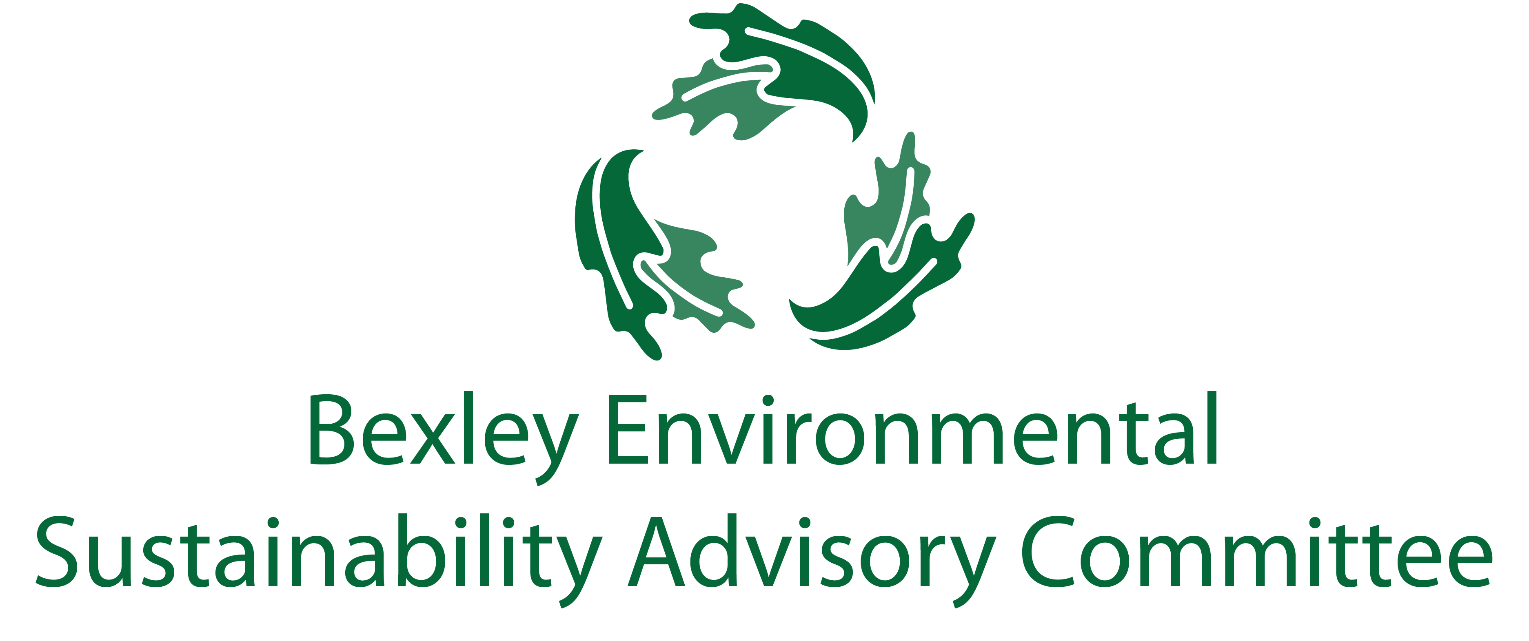

February 22, 2022

6:00 pm, your house

Meeting Agenda

Zoom Link:

<https://us02web.zoom.us/j/83230101467?pwd=aFVqM3dCcXJNaVlkS3FySVowZkhHZz09>

1. Roll Call & Introductions:
2. Major Goals Update

* 1. ESAC reorganization (Rebecca)
  2. Redefining ESAC
  3. Food Waste Recycling Program (Steve/ Jo Anne)
  4. Litter/Trail Clean Ups (Kathy and Addison)
  5. Mosquito Spraying (Rebecca)
  6. Climate Action Plan (Carol, Drew, Rob, Kessler, Elizabeth)
  7. Bike Friendly Bexley
  8. Forum (Steve)
  9. LYA (Rebecca)
  10. Yes You Can (Rebecca)
  11. Sustainability Programs Coordinator (Elizabeth)

1. Other Updates
   1. Chamber Update (Lesli)
   2. Schools Update (Jen, John, Midge, Ashley)
2. Updates from Things off the Table
3. Successes
4. Announcements
5. Free Thinking- Big Ideas Brainstorm Time
6. Adjourn

The Bexley community will significantly reduce its contribution to the landfill through sustainable initiatives for residents, businesses, institutions, and industries by improving public engagement, education, and infrastructure (ZWP 2-1)

**The City of Bexley will accomplish the Zero Waste objective by 2040 or sooner when it achieves a 90% reduction of materials disposed at the landfill.** The recommendations will be implemented in Phases and the ZWP will be updated by the City of Bexley Green Team every five years or earlier as determined by City Council (ZWP 1-6)

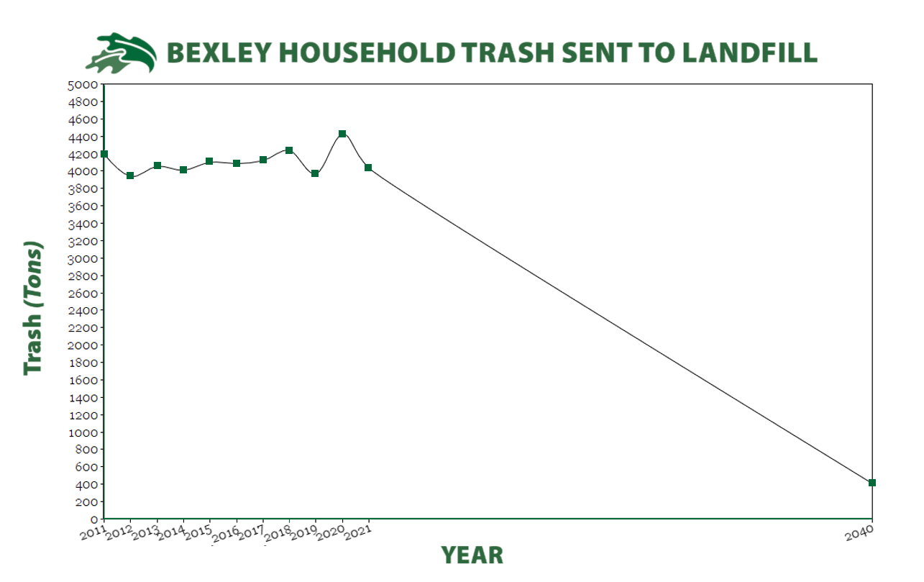

Note: Each sector also had its own list of objectives, which are typically to evaluate various things.

Green highlights are completed actions.

Red highlights are abandoned actions.

ZWP to be updated 5 years from 2017/2018, or sooner, as Council deems appropriate.

Recommended Actions for Residential Sector (3-21 and 3-22)

|  |  |  |
| --- | --- | --- |
| Phase 1 (2018-2023) | Phase 2 (2024-2030) | Phase 3 (2031-2040) |
| Toters for single family homes | MFH Recycling |  |
| Contract reviewed and pay-as-you-throw and semi or fully automatic collection explored | Contract reviewed and pay-as-you-throw and semi or fully automatic collection explored |  |
| Back yard composting encouraged | SWACO addressing hard-to-recycle materials (including plastics 3-7) |  |
| Yard waste collection at curb for those not interested in back yard composting |  |  |
| Composting pilot program for residents and businesses |  |  |
| Educational program emphasizing existing collection opportunities for HHW, electronics, textiles |  |  |
| Explore partnership with other communities for textile recycling |  |  |
| Reducing plastic bags |  |  |
| Electronics drop-off |  |  |
| Increase data collection to issue plan and complete studies |  |  |
| Eliminate backdoor service |  |  |

Recommended Actions for Business Sector (4-19 and 4-20)

|  |  |  |
| --- | --- | --- |
| Phase 1 (2018-2023) | Phase 2 (2024-2030) | Phase 3 (2031-2040) |
| Get info re recycling for businesses | Establish Green Teams within commercial and Industrial business |  |
| Form stakeholder group to discuss topics | Develop business plan with tasks and dates for recycling |  |
| Implement mandatory recycling | Conduct general business-specific waste audits |  |
| Expand reuse and source reduction of waste materials within businesses | Implement special waste recycling and reuse programs to manage special wastes, including electronics |  |
| Develop short and long term business plans for commercial and industrial compost | Work with businesses to improve contracting, auditing and dumpster service |  |
| Conduct inventory of businesses to be targeted by compost program | Conduct selected waste audits for one or more targeted businesses |  |
| Require policy for pairing of trash and recycling containers | Revise long term plan if necessary based on pilot project results |  |
| Promote education and development of greater plastics recycling | Adopt policies promoting purchase of recycled-content, or environmentally sustainable products. |  |
|  | Establish specifications for all construction projects which require construction and demo debris to be reused or recycled |  |
|  | Develop communication plan as part of education program targeted at business owners and waste management programs. |  |

Recommended Actions for Educational Sector (5-18 and 5-19)

|  |  |  |
| --- | --- | --- |
| Phase 1 (2018-2023) | Phase 2 (2024-2030) | Phase 3 (2031-2040) |
| Contracting, auditing, and dumpster service | Construction and demo debris |  |
| Purchase recycled-content products | Events |  |
| Waste sorts |  |  |
| Special Wastes |  |  |
| Reuse and waste reduction |  |  |
| Data collection |  |  |
| Communication Plan |  |  |

Recommended Actions of City (5-26)

|  |  |  |
| --- | --- | --- |
| Phase 1 (2018-2023) | Phase 2 (2024-2030) | Phase 3 (2031-2040) |
| Create ESAC | Contracting, auditing, and dumpster service |  |
| Website | Construction/Demo policy |  |
| Recycling containers- consistency | Policy for purchasing recycled-content products |  |
| “Green” special events |  |  |

Recommended Education and Promotion of ZWP (6-8)

|  |  |  |
| --- | --- | --- |
| Phase 1 (2018-2023) | Phase 2 (2024-2030) | Phase 3 (2031-2040) |
| Establish Education and Outreach Planning Subcommittee | Create education signs to brand ZWP for high traffic areas |  |
| Develop schedule to present ZWP to community | Provide businesses that recycle a sign to advertise |  |
| Develop specific plan for informing residents about new programming |  |  |
| Work with BCS to schedule professionals to educate students and faculty |  |  |
| Work with Capital Sustainability Council establish data needs and working relationship with City |  |  |
| Coordinate with IT for social media material |  |  |
| Web based directory |  |  |
| Create list of local haulers for commercial sector have this listed online |  |  |
| Map out Drop-off recycle locations within 2 mile radius |  |  |