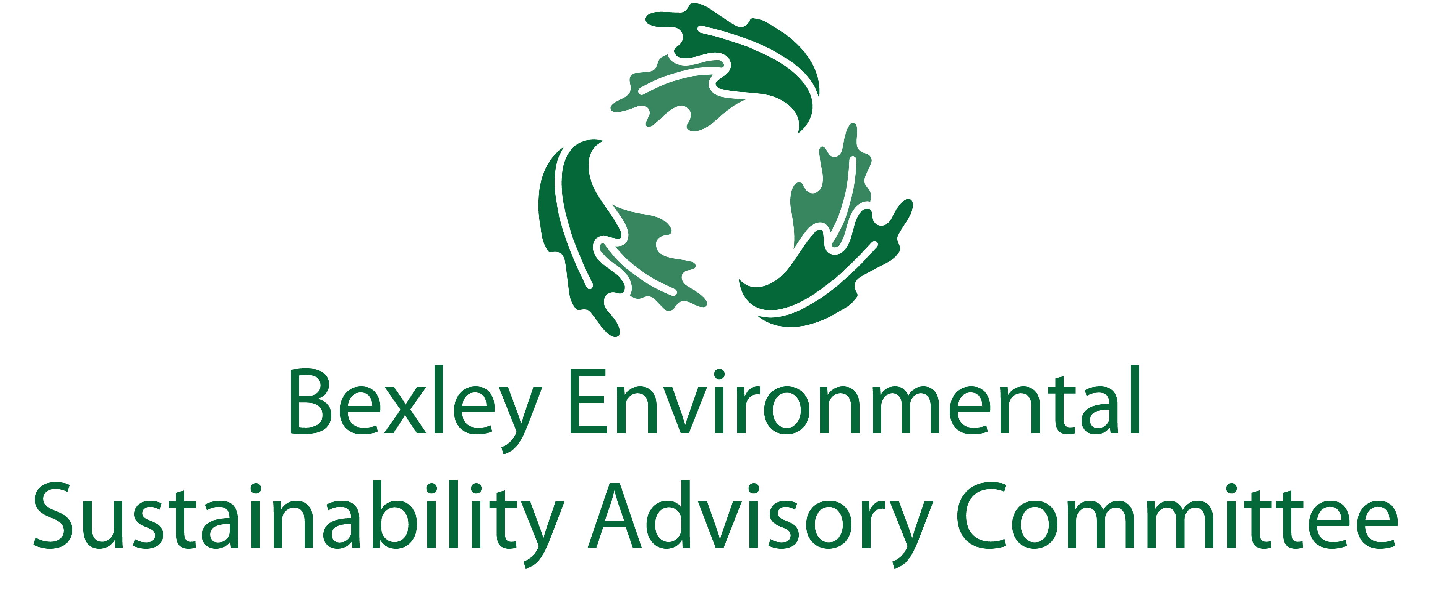
April 21, 2020
6:00 pm, The Comfort of Your Home
Meeting Agenda
- Roll Call & Introductions

- Major Goals Update
  - Single Use Plastic Bag Ban (Ben)
  - OSU Student Studies (Elizabeth/Ben)
    - Universal Recycling
    - Drop-Off Facility
  - Food Waste Recycling Program (Elizabeth/Ben)
  - Communications and General Community Education Update (Elizabeth)
  - Chamber update (Lesli)
  - Schools (Jen, John, Paul, Youting, Sophia)

- Other Updates
  - Programming
    - COSI Big Science Celebration (Elizabeth)
    - Residential PACE (Ben)
    - Green Bexley Fair
    - Bootcamp
  - The Bexley Bag (Ben)
  - ESAC Membership/ Structure (Elizabeth)
  - Bike Repairs and Donations Assistance (Ben)
  - Daycare (Midge)
  - GHG Goals (Carol)

- Successes

- Free Thinking- Big Ideas Brainstorm Time

- Announcements

- Adjourn
  - Next meeting is May 19th at 6:00 pm.

