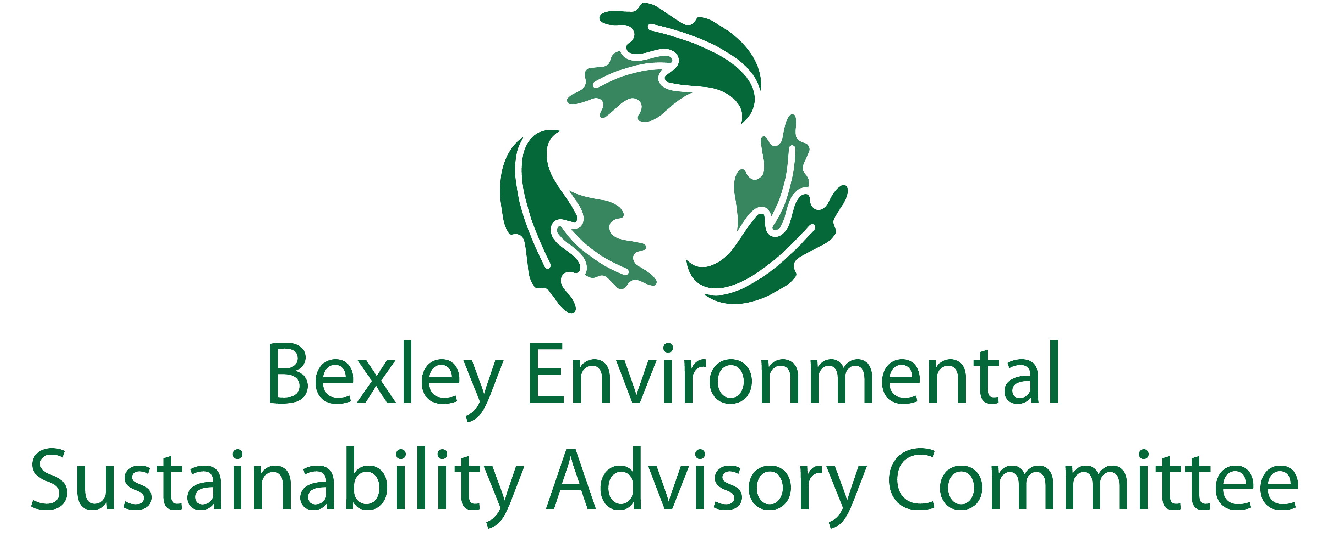
February 26, 2019
6:00 pm, Bexley City Hall
Meeting Agenda

- Roll Call & Introductions
- Current Events

- Guest- Kyle O’Keefe, SWACO Director of Innovation and Programs

- Major Goals Updates
  - Business Workshop Briefing (Ben, Troy, Lesli)
    - Plastic ban & universal recycling discussions
  - Food Waste Recycling Program
    - Food Waste Recycling program update (Ben, Bill)
    - Food waste recycling community outreach (Joanna and Jo Anne )
  - Sustainability Fair/Week
    - Sustainability Week (April 22nd- April 27th) – Kathy, Carol, Rebecca, Elizabeth
  - Communications & General Community Education update (Elizabeth)
  - Drop off Bins update (Elizabeth)
  - SWACO Community Waste Reduction Grant (Steve)
  - Chamber update (Lesli Mautz)
  - School Committee (Jim, Paul)
  - Badges/seal for businesses (Lesli, Joanna)

- New Members

- Successes

- Free Thinking – Big Ideas Brainstorm Time
- Adjourn
  - Next meeting is March 19 at 6:00 pm

