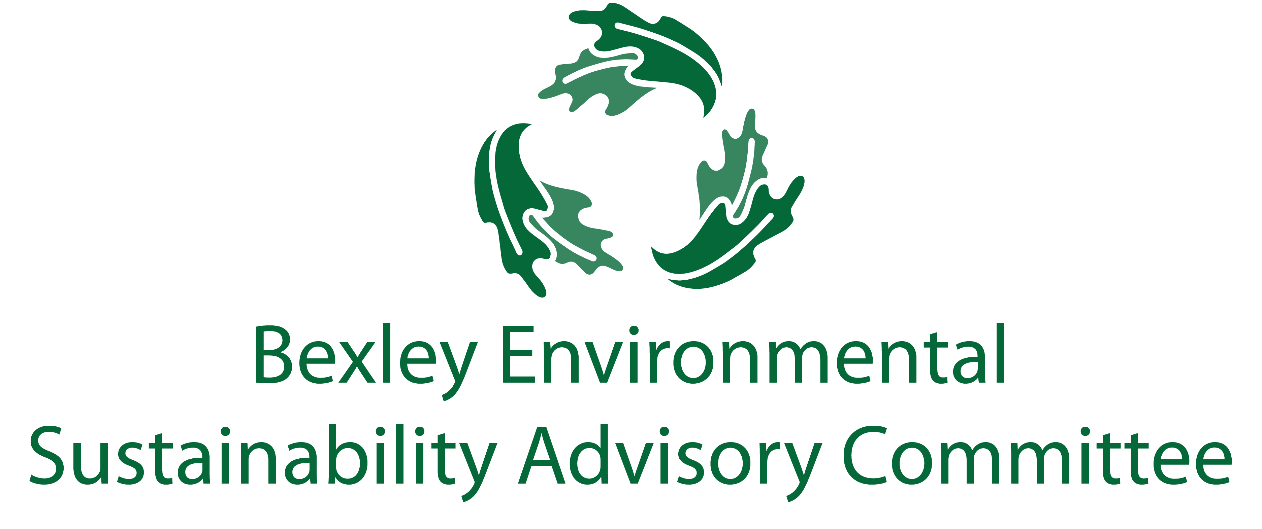

August 21, 2018

6:00 pm, Bexley City Hall

Meeting Agenda

1. Roll Call & Introductions
2. Ray Leard – Innovative Organics – Presentation on Bexley’s curbside food waste program
3. Ohio EPA Meeting Briefing – Steve Grossman
4. Major Goals Updates
   1. Food waste recycling community outreach - Joanna and Jo Anne
   2. Community education regarding plastic bad use – Jo Anne and Troy
   3. Draft ordinance for plastic bag ban – Ben
   4. Solar PACE program update - Ben

|  |  |
| --- | --- |
| **Prioritize Reduce & Reuse before even "Recycle" + add "Rethink"** | **Captains** |
| Roll out community-wide food waste recycling | Joanna, Jo Anne |
| Have a committee of the schools - Capital, CSG, Bexley Schools, St Charles | Jim, Paul |
| Single Use Plastics Ban - research and promote | Troy, Ben, Jo Anne |
| Mandatory commercial and MF recycling | Carol, Ben |
| Web-based directory of recycling options & explore needs for Bexley - Promote alternative recycling options (i.e. Gimme 5, corks, etc) | Elizabeth, Steve, Sam M. |
| Educate community on waste management | Elizabeth |

|  |  |
| --- | --- |
| **Climate** |  |
| Help promote PACE solar program | Drew, Steve, Ben |

|  |  |
| --- | --- |
| **Education/Outreach** |  |
| Environmental Fair - help promote with some "giveaways", maybe semi-annual? | Elizabeth, Carol |
| Badges/seal for waste management practices for businesses | Lesli, Joanna |

1. Free Thinking – Big Ideas Brainstorm Time
2. Adjourn