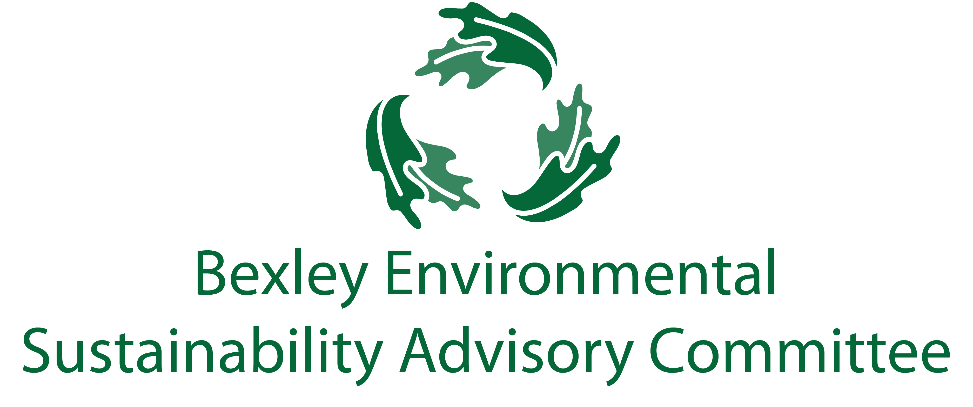

July 17, 2018

6:00 p.m., Bexley City Hall

Meeting Agenda

1. Roll Call
2. Workshop – Goals Prioritization
3. Sustainability Intern – Marihah Abdullah – Presentaion on:
   1. Single Use Plastics Bans
   2. Mandatory Commercial Recycling
4. Free Thinking – Big Ideas Brainstorm Time
5. Adjourn