**Jeffrey Mansion Alcohol Policy Framework**

**Revised March 26, 2019**

It is the intent of this Jeffrey Mansion Alcohol Policy Framework to allow for limited and responsible permitting of alcohol at Jeffrey Mansion during special events at the mansion.

**Role of the Recreation Board**

The Recreation Board shall author and administer a Jeffrey Mansion Alcohol Policy. The Recreation Board has the right to define and restrict the Jeffrey Mansion alcohol policy beyond the framework outlined herein.

In addition to, or as a part of, the Recreation Board created Jeffrey Mansion Alcohol

Policy, the Recreation Board shall establish clear internal standards and directives to

address the following:

* **Evaluation:** Prior to the enactment of a Jeffrey Mansion Alcohol Policy, the

Recreation Board shall establish a process and standards by which to regularly

evaluate the effectiveness of the alcohol policy in promoting responsible

stewardship of the mansion facility and the city’s financial position.

* **Enforcement:** The Recreation Board shall establish methods by which to enforce

responsible conformance to the Jeffrey Mansion Alcohol Policy by users of the

facility.

* **Communication:** Requirements of users of the Mansion and enforcement

measures must be clearly communicated in rental forms, etc., and in any promotional materials.

* **Creation and Modification of the Jeffrey Mansion Alcohol Policy:** The Jeffrey

Mansion Alcohol Policy will not go into effect until voted on and passed by a

simple majority of the Bexley Recreation Board. Any changes of the policy

thereafter will also require passage by a simple majority of the Bexley Recreation

Board.

* **Legal Issues:** The Recreation Board shall have the draft Jeffrey Mansion Alcohol

Policy reviewed by legal counsel prior to submittal to Bexley City Council for

review.

**Rental Rate Structure**

It is not the intent of this policy to alter rental rates for events in which alcohol is not being permitted. Therefore, rental rate structures for Jeffrey Mansion will remain the same except for the following changes:

* An alcohol surcharge will be assessed to any event that would like to have the use of alcoholic beverages. The alcohol surcharge rate shall be established by the Recreation Board.

**Frequency, Days, and Hours of Permitted Use**

* Rentals in which the serving of alcohol is permitted will be required to fall into specific time windows on Fridays, Saturdays and Sundays.
* All weekend events with alcohol must end by 11:30 pm.
* The Recreation Director, with approval from the Mayor, may permit alcohol rentals on Mondays, Tuesday, Wednesdays, and Thursdays, with an ending time of no later than 11:00 pm.
* Holidays are exempt from the designated end time.
* Only one private alcohol event can occur in the Mansion at the same time.

**Additional Restrictions on Rentals of the Lower Level Carriage Court**

* Events in which alcohol is permitted and the number of guests exceeds the current Main Level maximum occupancy of 128 people requires a parking plan which may include valet parking at the cost of the renter.

**The annual event limitation does not include:**

● Community events/city sponsored events such as, but not limited to, the BCF Annual Event, Mayor and Solicitors Dinner, DARN Shop Hop, etc.

**Designated Areas for Events within Jeffrey Park**

* The Recreation Board may permit up to two events per year within the Jeffrey Park grounds which are open to the public and free of charge for general admission during which the serving of alcohol is permitted.

**Approved Caterers**

A list of approved preferred caterers will be created for events.

* Preferred caters will be required to obtain and maintain personal injury and/or

property damage liability insurance coverage of no less than a $1,000,000;

automobile liability insurance of an amount no less than $1,000,000; and liquor

liability insurance of no less than $1,000,000. The City of Bexley shall be included as

an additional insured on the caterer’s certificate of insurance.

* Caterers will pay a fee, as determined by the Recreation Board, to the Recreation Department for each event at which they serve.
* In order to have alcoholic beverages at an event, customers must work with one of

the preferred caterers.

* Approved caterers will be interviewed and pre-approved by the Bexley Recreation

Board.

* In order to remain on the preferred caterer’s list, the caterer must leave the

mansion in the condition it was in prior to the event, to the satisfaction of the

Recreation Director.

**Caterer’s Responsibility**

* Caterers will have a separate contract with customers from that of the rental contract.
* Customer will make a payment to the Bexley Rec for the Jeffrey Mansion and a payment to the preferred caterer of choice for food services.

**Security**

* Private alcohol events may be required to have a minimum of one security staff at the discretion of Bexley Recreation and Parks (BRP) staff. BRP staff reserve the right to require additional security staff.
* Priority for security coverage will be given to Bexley police officers.
* Alcohol consumption must comply with all Bexley Ordinances, Ohio Revised Code, and any and all governing laws.
* Security staff and BRP staff retain the authority to order the renters/participants to cease all activities and leave the premises if it is determined that is in the best interests of safety.

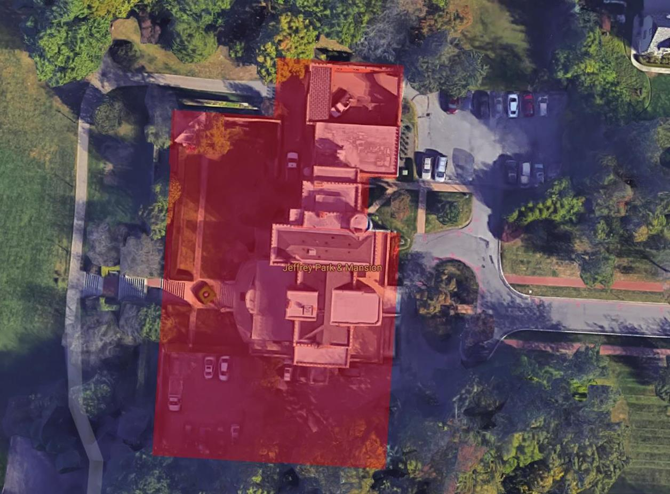**Designated Areas**

* Alcohol consumption is strictly limited to designated areas. The designated areas specified in this policy may be further restricted by action of the Recreation Board. These areas include the Jeffrey Mansion building including the carriage court expansion on the north side of the building, adjacent patio, south parking lot and the adjacent first landing located on the west side of the Jeffrey Mansion (Landing with the gazebo). The designated areas are shaded red in the aerial photograph below:

**Review of the Jeffrey Mansion Alcohol Policy by Bexley City Council and Mayor**

* Within 30 days prior to voting on the passage of a new or modified Jeffrey

Mansion Alcohol Policy, the Recreation Board shall provide members of Bexley

City Council and the Mayor of Bexley a written copy of the same for review and

comment.

**Notice to Area Residents for Proposed Changes to the Jeffrey Mansion Alcohol Framework**

* If legislation is introduced at Bexley City Council to amend the Jeffrey Mansion Alcohol Policy Framework, notice will be mailed to Bexley residents within 500’ of Jeffrey Mansion no later than 7 days after introduction of the legislation.