Board of Zoning and Planning

September 23, 2021

Staff Report

Kathy Rose

Old Business

1. Application No.: BZAP-21-36

Applicant: Brent Foley

Owner: St Charles Location: 2010 E. Broad St.

BZAP Request: The applicant is seeking a Certificate of Appropriateness for a master plan, and approval of landscape and lighting plans as part of the west parking lot modifications.

Staff Report by Jason Sudy

New Business

1. Application No.: BZAP-21-28

Applicant: Ji Liu

Owner: Ji Liu

Location: 407 Northview

BZAP Request: The applicant is seeking approval of a lot split to separate lots 19 and lot 20; in the Second Ruhl subdivision, to take it back to the original lots of record and includes a vacated right-of-way along the south side of lot 19.

The applicant has received a conditional Certificate of Appropriateness; to allow the existing deteriorating structures to be demolished and a New Single-family dwelling to be constructed.

One of the conditions of the approval (#7) The owner must combine the parcels OR request a councilmatic variance from the R-3 lot size, and a lot split from the Board of Zoning and Planning.

Bexley Code Section 1226.02 (c) Lots in Combination. If a vacant nonconforming lot or parcel in any district adjoins one or more lots or parcels in common ownership…… such lots shall be replatted and such parcels shall be combined to create conforming or more conforming lots and/or parcels as a prerequisite for development.

Background regarding code:

I have discovered several original lots of record throughout the city that, in my opinion, are neither large enough or properly dimensioned to build upon; yet code viewed an original lot of record as a buildable lot.

There are also lots that had common ownership, had a principal structure that met the setbacks of the combined lots. If the principal structure is located on one lot and the other lot is sold, the principal structure may no longer meet code (for lot coverage and/or encroached on the newly created “side” property line per zoning core and in some cases the fire safety code. This type of situation should be prevented by a review process, prior to a vacant adjoining lot being sold.

Code Section 1226.02 was added to the Zoning Code in 2016 – to prevent nonconformities when it is not appropriate.

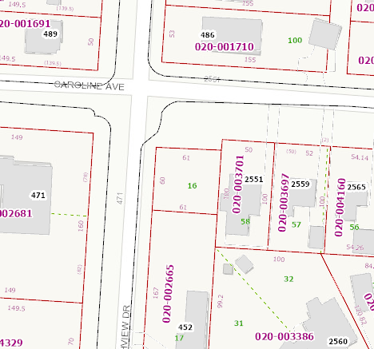

**61’ x 60’ Corner Lot 16 – owned by parcel to the right 020-003701 R-6 Zoning**

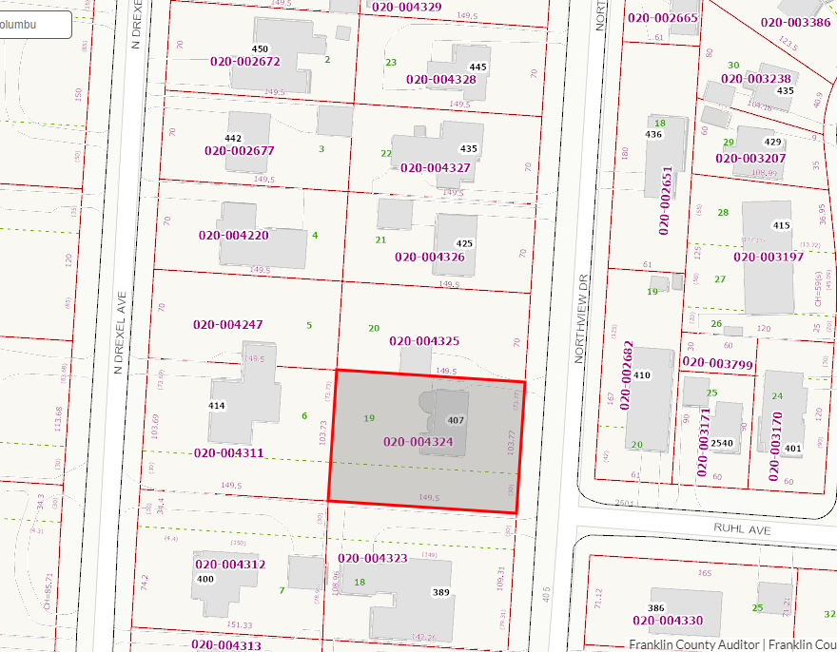

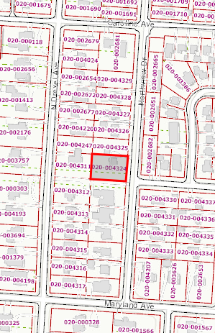

R-3 Zoning has a minimum lot size of 90’ x 160’ (14,400sq’). The lots in this block range in size from 78’ x 149’ (11,622sq’) at the north end, to 75’ x 139’ (10,425sq’) at the south end

The New structure, as approved by the ARB, will meet all of the R-3 zoning code requirements for lot 19, which is the south lot. The applicant is looking to split the lot in order to make the north lot (20) available for development.

The lots to the north of lot 20 are fairly consistent in size with lot 20 and are existing non-conforming.

The lots to the south of lot 19 are all fairly consistent with lot 19 (minus the vacated easement) and are also existing non-conforming.

If the lot split is approved, these lots will go back to what was the original lot of records, with the additional 30’ x 149.5’ easement, for a 103.77’ x 149.5’ (15,513 sq’ lot ) which exceeds the minimum lot square footage, is not the standard dimensions, but is more conforming .

City Council had a Public Hearing on September 21st at which time they discussed the lot size variance. The variance request submitted in Resolution 10-21, will be voted on at the September 28, 2021 City Council meeting.

Conditions:

If the Board finds it appropriate to grant a lot split, it should be subject to City Council approval of the variance to the R-3 lot size requirements requested under Resolution No. 10-21.

1. Application No.: BZAP-21-37

Applicant: Brenda Parker

Owner:

Location: 809 S. Cassingham

BZAP Request: The applicant is seeking architectural review and approval of a new screen porch over an existing deck and a new roof on an existing 2nd floor sleeping porch. The applicant is also seeking a variance from Bexley Code Section 1252.09 (R-6 zoning) ; which requires a 6’6” setback from the side yard property line for a 40’ wide lot, to allow a screen porch to be constructed on the existing deck which is located 5’ 1” from the north side property line.

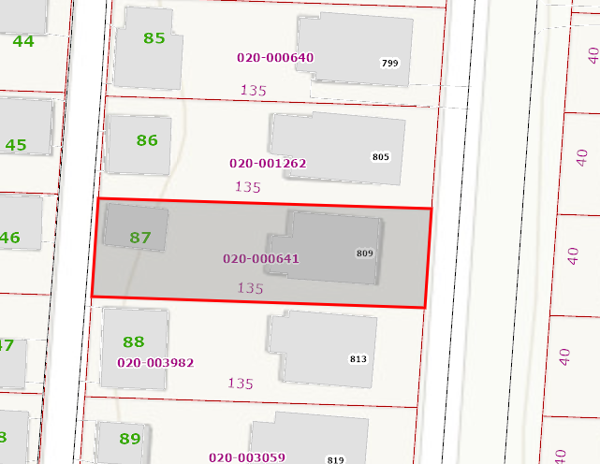

Staff has provided a map to show the spacing of the homes in this block. The Standard setback requirement from the side yard property line is 1/6 of the lot width, but need not exceed 8’. Code allows an uncovered deck to encroach 4’ into the required setback from the side yard property line; which could place the deck 2’ from the side property. The deck is currently not encroaching, but by adding the screen porch, it would then be encroaching1’ 5” into the required setback for an enclosed structure.

From what I can tell there are no violation to the fire code; which requires a 5’ separation between neighboring structures, should the Board finds it appropriate to grant a variance to allow the screen porch to be constructed on the existing deck.

I would defer to Karen for any design comments relating to the roof modification on the sleeping porch.

1. Application No.: BZAP-21-38

Applicant: Susan Hunter & James Gray

Owner: Capital University

Location: 2199 E. Main St. – Blackmore Library

BZAP Request: The applicant is seeking architectural review and approval from the Board of Zoning and Planning, to allow a temporary banner to be posted on the west wall of the Blackmore Library building; in this case it is to announce a new Mascot. The applicant is also seeking a variance from Bexley Code Section 1260.07(b)(2), which limits a non-residential temporary sign to 64 square feet in area, to allow a 600 square foot temporary banner on the west wall of the Blackmore Library building. The applicant is also requesting future banners (2 per year maximum) subject to Staff Design Review, if the Board finds the size and location appropriate to grant a variance.

Staff would like to point out that the University has had a prior displays related to the University on the wall of the Blackmore Library. We reached out to them to provide the process for future displays that would need to be submitted to the BZAP for review.

Staff finds that the current request for the announcement of a new mascot to be appropriate and why we have this application before the Board at this time.

The fact that they also would like to request future banners might be something we need to discuss to see what the Board may find acceptable, based on the following criteria:

1) The proposed frame and it’s color.

2) Allow future banners to be attached to the wall mounted bracket.

3) The length of time the banner should be displayed.

4) The size.