**Immunization Program/School Nursing Section**

**Adult, Childhood and COVID-19 Vaccination Clinics**

In June 2023, 172 clients were vaccinated at FCPHs routine adult and childhood vaccination clinics, and 412 vaccines were administered. A total of 15 COVID-19 vaccines were administered. Flu vaccinations continue to be offered at all clinic locations. There were a total of 130 reminders and recalls completed for the immunization clinic.

From April 1, 2023-June 30, 2023, a total of 9 immunizations were administered to residents residing in the 43209 zip code.

The immunization clinic has expanded its hours, which are reflected on the agency’s website. This includes several back-to-school clinics on the following dates:

Saturday, August 12, 2023, from 9:00 am-12:00 pm

Monday, August 28, 2023, from 5:00 pm-8:00 pm

Saturday, September 9, 2023, from 9:00 am-12:00 pm

Monday, September 18, 2023, from 5:00 pm-8:00 pm

**Get Vaccinated Ohio – Public Health Initiative Grant**

For the 2023-2024 school year, 9 Bexley school staff were trained on the Ohio’s immunization entry requirements.

**Maternal and Child Health Section**

**CMH Program-Home Visits and Safe Sleep**

Franklin County Public Health (FCPH) administers the Children with Medical Handicaps (CMH) program to children ages 0-23 years old living in Franklin County. The PHNs in the CMH program provide case management services for children with special health care needs. These services include assisting families with finding quality health care for their children, providing community resources, participating in community outreach and assisting with coordination of care for children with various healthcare needs. CMH PHNs provide services via telephone communication, email communication, mail and home visits.

From April 1, 2023-June 30, 2023, a total of 10 families residing in Bexley were provided case management services.

In June 2023, CMH PHNs completed 13 home visits with clients and their families. There were 4 portable cribs distributed by trained FCPH staff to families in need of a safe sleep space for their infant. Additionally, 6 Safe Sleep Assessments were conducted by Maternal and Child Health (MCH) staff with families who had an infant under the age of 1 in the home.

**Community Partnership Grants**

The PHN Led Home Visiting program continues to collaborate with Heart of Ohio Family Health with funding provided by the Franklin County Board of Commissioners. FCPH was notified of additional funding awarded to the program which will allow us to increase the number of clients being served to 120 individuals and their families, as well as hire 1 Public Health Nurse, 2 Community Health Workers, 1 Data Analyst, and 1 Public Health Nurse Supervisor.

FCPH continues to partner with Restoring Our Own Through Transformation (ROOTT) through a separate Community Partnership grant opportunity provided by the Franklin County Board of Commissioners. ROOTT provides prenatal doula services to Black individuals within Franklin County.

**Infectious Disease Section**

**COVID-19 Response Updates**

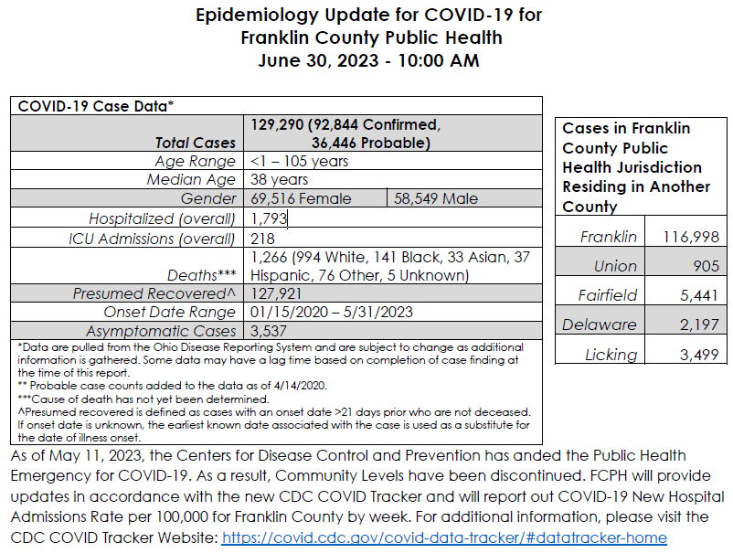

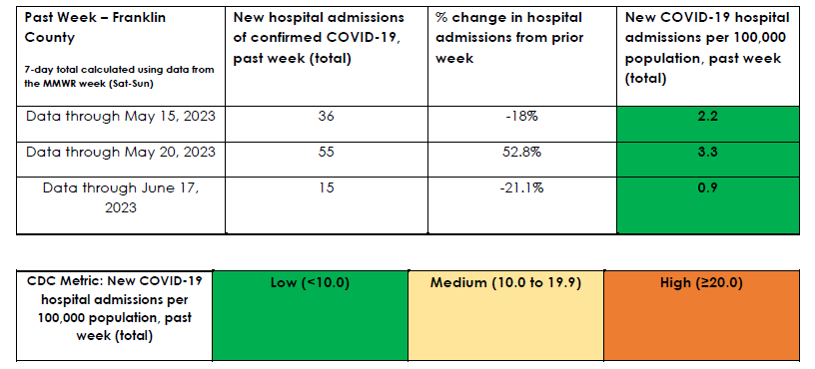

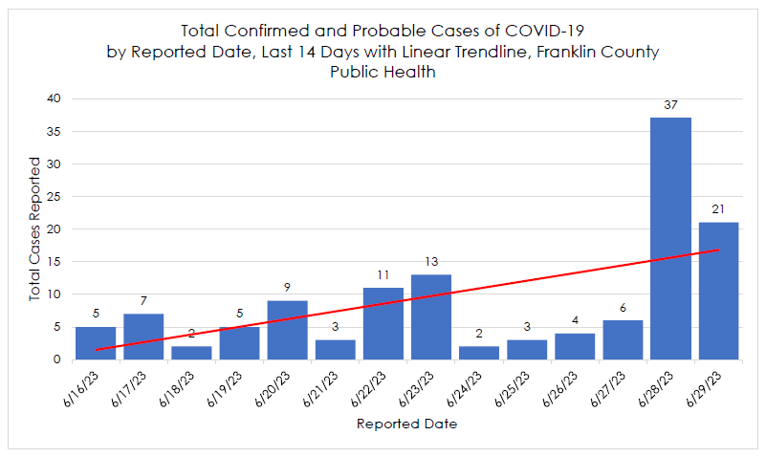

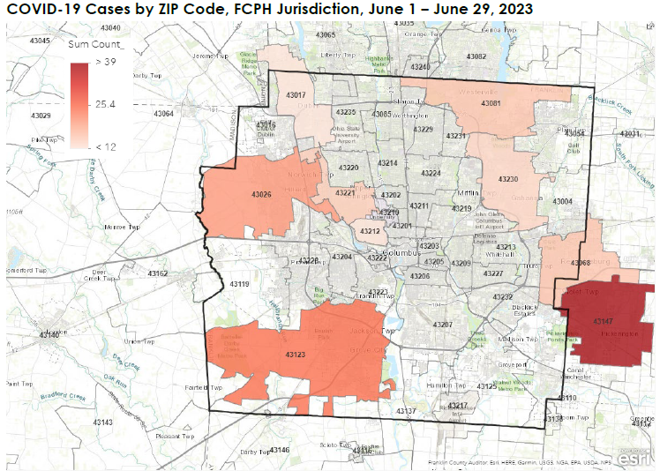

**Cyclosporiasis Illness in the United States, 2023**

* CDC, FDA, and state and local partners investigated an outbreak of cyclosporiasis cases in Georgia and Alabama linked to raw broccoli that included 20 illnesses. People reported eating broccoli in the 14 days before they got sick. [FDA](https://www.fda.gov/food/outbreaks-foodborne-illness/investigations-foodborne-illness-outbreaks) and state and local partners conducted traceback investigations and determined that the broccoli was imported.
* As of June 22, 2023,
  + 210 illnesses
  + 20 hospitalizations
  + Zero deaths
  + 22 states reporting cases
* FC case counts
  + A total of 9 reported cases in 2022. FCPH (4) CPH (5)
  + Currently, FCPH has 5 reported cases between May- July 2023. 2 travel-associated and 3 US acquired. CPH has 7 reported cases between June-July 2023.
  + Linking cases to the national outbreak and further genotyping at the laboratory will take some time.
* **Symptoms** 
  + Symptoms usually start within 2 weeks after eating food contaminated with *Cyclospora*.
  + People typically experience watery diarrhea. They may also experience loss of appetite, cramping, bloating, increased gas, nausea, and fatigue.
  + Symptoms can persist for several weeks to a month or more. If untreated, symptoms may get better for a while and then return, and this pattern may repeat.

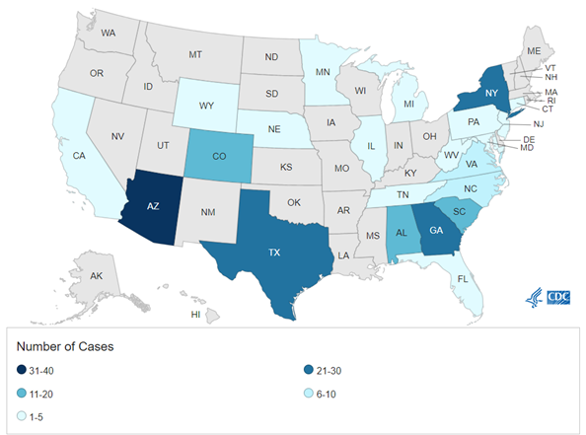

Source: <https://www.cdc.gov/parasites/cyclosporiasis/outbreaks/2023/map.html>

**Guidance on Measles during the Summer Travel Season – HAN Alert by CDC on 6/21/2023**

* As of June 8, 2023, CDC has been notified of 16 confirmed U.S. cases of measles across 11 jurisdictions, with
* 14 cases (88%) linked to international travel.
* Based on current estimates, twice as many Americans are planning to travel internationally in 2023 compared with 2022.
* Many countries and popular travel destinations, such as London, England, have experienced measles outbreaks in recent years.
* The United States has seen an increase in measles cases during the first 5 months of 2023, with 16 reported cases compared with 3 in 2022 during the same period.
* Most of these cases were among children who had not received measles-mumps-rubella (MMR) vaccine.

**Locally Acquired Malaria Cases Identified in the US– HAN Alert by CDC on 6/26/2023**

* Identification of locally acquired malaria cases in two U.S. states Florida and Texas within the last 2 months.
* Concern for a potential rice in imported malaria cases associated with increased international travel in summer 2023.
* Need to plan for rapid access to IV artesunate, which is the first-line treatment
* Locally acquired mosquito-borne malaria has not occurred in the US since 2003 when eight cases of locally acquired P. vivax malaria were identified in Palm Beach County, FL.
* Despite these cases, the risk of locally acquired malaria remains extremely low in the United States. However, Anopheles mosquito vectors, found throughout many regions of the country, are capable of transmitting malaria if they feed on a malaria-infected person

Respectfully submitted by Alex Jones, Assistant Health Commissioner/Director of Prevention & Wellness, July 6, 2023.