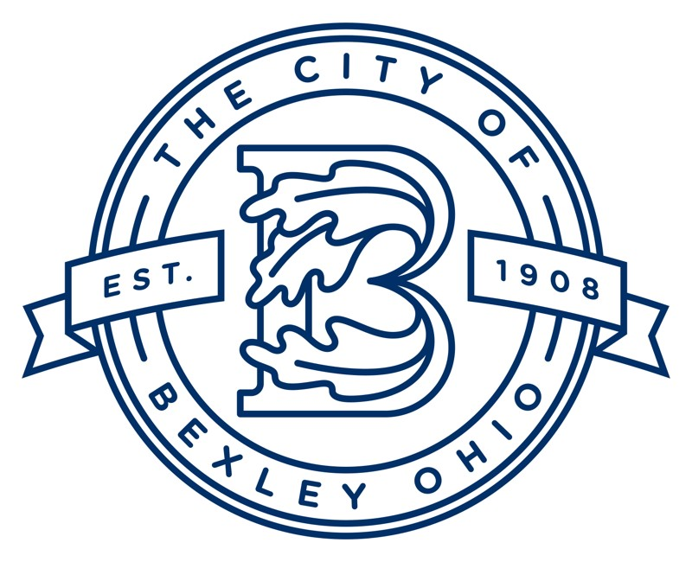

Board of Control Meeting Agenda

Friday, March 7, 2025

1. Call to Order
2. Roll Call of Members
3. Review of quotes for Sewer flow metering and modeling
4. Review of updated pricing for aggregation
5. Old Business
6. New Business
7. Adjourn